A MULTI-MODAL FRAMEWORK FOR QUANTIFYING NARRATOR RELIABILITY IN ʿILM AR-RIJAL USING SEMANTIC SENTIMENT ANALYSIS AND GRAPH NEURAL NETWORKS

ALAN SYAHMI BIN SANIH @ SANI

FACULTY OF COMPUTING AND INFORMATICS UNIVERSITY MALAYSIA SABAH

2026

NAME : ALAN SYAHMI BIN SANIH @ SANI
MATRIC NUMBER : BI23110344
TITLE : A MULTI-MODAL FRAMEWORK FOR QUANTIFYING NARRATOR RELIABILITY IN ʿILM AR-RIJAL USING SEMANTIC SENTIMENT ANALYSIS AND GRAPH NEURAL NETWORKS
DEGREE : BACHELOR OF COMPUTER SCIENCE WITH HONOURS
(DATA SCIENCE)
VIVA’S DATE : 30 JUNE 2027

CERTIFIED BY;

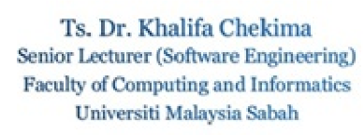
1. SUPERVISOR Signature

DR. KHALIFA CHEKIMA

DECLARATION

I hereby declare that the material in this thesis is my own except for quotations, equations, summaries and references, which have been duly acknowledged.

30 APRIL 2026
ALAN SYAHMI BIN SANIH @ SANI
BI23110344

ACKNOWLEDGEMENT

“خَيْرُ النَّاسِ أَنْفَعُهُمْ لِلنَّاسِ”
“The best of people are those who are most beneficial to others.”
– Prophet Muhammad ﷺ
(At-Tabarani in Al-Muʿjam al-Awsat Hadith: 5787, graded Ṣaḥīḥ by Al-Albani)

All praise and gratitude belong to Allah for giving me the strength, patience, and clarity to complete this proposal. This work is a small attempt to serve the tradition of ʿIlm ar‑Rijal, and I pray that it benefits others in some way.
I would like to express my deepest thanks to my supervisor, Dr. Khalifa Chekima, for his guidance, patience, and honest feedback throughout this journey. He gave me the freedom to explore an ambitious idea while quietly making sure I didn’t go off the rails.
I am also grateful to the researchers and developers behind the OpenITI corpus, Shamela Digital Library, and CAMeL Tools, as their work made this project possible in the first place. Likewise, I thank the authors of the AR‑Sanad 280K dataset and the Ifta’ Sunnah platform for making high‑quality Arabic Hadith data accessible to the research community.
To my parents and family: thank you for your endless prayers, for believing in me and for never doubting in my study years. This degree is as much yours as it is mine.
Finally, to my friends who listened to me ramble about Fiqh, madhabs and dalils, thank you for the many “spinning” sessions and for the generous amount of ideas we all made.
May Allah accept this small effort of mine, forgive my shortcomings, and make it beneficial to those who study His religion.

Alan Syahmi Bin Sanih @ Sani
8th May 2026

ABSTRACT

The authentication of Prophetic reports (Ḥadīth) through the science of narrator criticism (ʿIlm ar‑Rijal/Jarḥ wa Taʿdīl) is a cornerstone of Islamic scholarship, yet the digital era has outpaced manual verification methods. This project proposes a multi‑modal framework that automates narrator reliability scoring by integrating three computational modalities: Arabic Named Entity Recognition (NER) using a fine‑tuned AraBERT v2 model to extract narrator names, kunya, and nisba from classical biographical texts (Taqrīb at-Tahḏīb of Ibn Ḥajar al-ʿAsqalāni and the Tahḏīb al-Kamāl of al-Mizzī) and isnād chains (AR‑Sanad 280K); a Knowledge Graph (KG) constructed with NetworkX (~1,500 narrator nodes, verbal edges e.g. heard_from and reported_from, rich attributes including tabaqa, travel history, and classical Jarḥ wa Taʿdīl labels) to enable structural and temporal integrity checks; and semantic sentiment quantisation that maps qualitative terms (e.g., Thiqa, Ṣadūq, Kaḏḏāb) to continuous reliability weights (0.00–1.00) and applies edge‑level risk modifiers (e.g., 0.80 for tadlīs). The final chain score is computed as the product of node weights and edge modifiers, then mapped to Ṣaḥīḥ/Ḥasan/Ḍaʿīf/Mawḍūʿ grades. Evaluation against ground‑truth gradings from the Kutub as‑Sitta (the Six Canonical Hadith Collections; i.e. Ṣaḥīḥ al‑Bukhārī, Ṣaḥīḥ Muslim, Sunan Abī Dāwūd, Jāmiʿ at‑Tirmiḏī, Sunan al‑Nasāʾī and Sunan Ibn Mājah) uses accuracy, F1, RMSE, and Cohen’s Kappa. The framework addresses the research gap of end‑to‑end automated trust scoring, providing an explainable, reproducible decision‑support tool for Ḥadith scholars.

Keywords: Hadith authentication, ʿIlm ar‑Rijal, Jarḥ wa Taʿdīl, Arabic NER, Knowledge Graph, Graph Neural Networks, semantic sentiment quantisation, multi‑modal framework

ABSTRAK

RANGKA KERJA MULTIMOD UNTUK MENGUANTIFIKASI KEBOLEHPERCAYAAN PERAWI DALAM ILMU RIJAL MENGGUNAKAN ANALISIS SENTIMEN SEMANTIK DAN RANGKAIAN NEURAL GRAF
Pengesahan riwayat-riwayat Nabi Muhammad (hadis) melalui ilmu kritik perawi (ilmu rijal/al-jarh wa al-ta’dil) merupakan suatu tunjang kesarjanaan Islam, namun era digital telah mendahului kaedah-kaedah pengesahan manual. Projek ini mencadangkan rangka kerja multimodal yang mengautomasikan penskoran kebolehpercayaan perawi dengan mengintegrasikan tiga modaliti pengiraan: Pengecaman Entiti Nama (NER) Bahasa Arab dengan menggunakan model AraBERT v2 yang ditala halus untuk mengekstrak nama perawi, kunyah dan nisbah daripada teks biografi klasik (Taqrīb al‑Tahḏīb karya Ibn Ḥajar al‑ʿAsqalānī dan Tahḏīb al‑Kamāl karya al‑Mizzī) serta rangkaian isnad (AR‑Sanad 280K); Graf Pengetahuan (KG) yang dibina dengan NetworkX (~1,500 nod perawi, tepi lisan seperti heard_from dan reported_from, atribut kaya seperti tabaqa, sejarah perjalanan, dan label Jarḥ wa Taʿdīl klasik) untuk membolehkan pemeriksaan integriti struktur dan temporal; dan kuantifikasi sentimen semantik yang memetakan istilah kualitatif (contohnya, Thiqa, Ṣadūq, Kaḏḏāb) kepada pemberat kebolehpercayaan berterusan (0.00–1.00) serta menggunakan pengubah suai tepi (contohnya, 0.80 untuk tadlīs). Skor rantai akhir dihitung sebagai hasil darab pemberat nod dan pengubah suai tepi, kemudian dipetakan kepada gred Ṣaḥīḥ/Ḥasan/Ḍaʿīf/Mawḍūʿ. Penilaian terhadap penggredan kebenaran daripada Kutub as‑Sittah (Enam Kitab Hadis kanonik iaitu Ṣaḥīḥ al‑Bukhārī, Ṣaḥīḥ Muslim, Sunan Abī Dāwūd, Jāmiʿ at‑Tirmiḏī, Sunan al‑Nasāʾī dan Sunan Ibn Mājah) menggunakan ketepatan, F1, RMSE, dan Kappa Cohen. Rangka kerja ini menangani jurang penyelidikan dalam penskoran kebolehpercayaan automatik dari hujung ke hujung, langsung menyediakan alat sokongan keputusan yang boleh dijelaskan dan dihasilkan semula untuk ulama hadis.
Kata kunci: Pengesahan Hadis, Ilmu Rijal, Al-Jarh wa al-Ta’dil, NER Bahasa Arab, Graf Pengetahuan, Rangkaian Neural Graf, kuantifikasi sentimen semantik, rangka kerja multimodal

TABLE OF CONTENTS

DECLARATION 2
ACKNOWLEDGEMENT 3
ABSTRACT 4
ABSTRAK 5
TABLE OF CONTENTS 6
LIST OF TABLES 11
LIST OF FIGURES 1
CHAPTER 1 1
INTRODUCTION 1
1.1 Overview 1
1.2 Problem Background 2
1.3 Problem Statements 4
1.4 Project Objectives 4
1.5 Project Scope 4
1.5.1 Data Sources 4
1.5.2 Scale and Dataset 5
1.5.3 Technical Scope 5
1.5.4 Application Domain Limitations 5
1.5.5 Out of Scope 6
CHAPTER 2: LITERATURE REVIEW 7
2.1 Hadith and its Structure 7
2.2 Impact of Hadith Grading 8
2.3 Hadith Authentication Process 9
2.4 ʿIlm ar-Rijal: An Expansive Biographical Study 10
2.5 Advancements in Arabic Named Entity Recognition (NER) 11
2.6 Knowledge Graphs (KG) for Entity Disambiguation 11
2.7 Advancements in Graph Neural Networks (GNN) for Isnād Analysis 12
2.8 Advancements in Semantic Sentiment Quantisation 13
2.9 The Research Gap: Automated Trust & Reliability Scoring 13
CHAPTER 3: PROJECT METHODOLOGY 15
3.1 Research Design 15
3.2 Dataset Corpus Characteristics 15
3.2.1 Textual and Label Distribution (NLP Dimension) 16
3.2.2 Graph Topology and Structural Sparsity (KG/GNN Dimension) 18
3.2.3 Spatiotemporal Metadata (Domain Dimension) 21
Geographic Concentration 23
3.2 Stage 1: Data Ingestion and Preprocessing 25
3.2.1 Data Sources 25
3.2.2 Biographical Text Parsing and Block Extraction 25
3.2.3 Two-Tiered Algorithmic Alignment Framework 26
3.3 Stage 2: Knowledge Graph Construction 27
3.3.1 Relational Graph Dimensions 27
3.3.2 Node & Edge Attribute Representation 28
3.3.3 Algorithmic Name Mapping (Alias & Ancestry Matcher) 28
3.4 Stage 3: Probabilistic Trust Scoring and Evaluation 28
3.4.1 Semantic Sentiment Analysis for Continuous Reliability Scoring 28
3.4.2 Unsupervised Graph Autoencoders (GAE) for Structural Representation Learning 32
3.4.2.1 GAE Architecture 32
3.4.2.2 GNN Uncertainty Modulation 33
3.4.3 Chain-Level Scoring (Soft Aggregation) 33
3.4.3.2 Base Chain Score ($Sbase$) 35
3.4.3.3 Chain-Level Penalty Modifiers 35
3.4.3.4 Final Chain Score ($Schain$) 36
3.4.4 Evaluation Protocol 36
3.5 Milestones and Dates 37
3.6 Gantt Chart 38
3.7 Tools and Technologies 39
CHAPTER 4: EXPERIMENT DESIGN 41
4.1 Research Methodology and Environment 41
4.2 Exploratory Data Analysis 41
4.2.1 Sanadset 650K Corpus 42
4.2.2 Kutub as-Sitta Ground-Truth Corpus 42
4.2.3 Biographical Encyclopaedia 42
4.2 Stage 1: Data Ingestion and Preprocessing Experiments 43
4.2.1 Experiment 1: Biographical Text Parsing 43
4.2.2 Experiment 2: Two-Tier Alignment Framework 43
4.3 Stage 2: Entity Linking and Graph Construction Experiments 44
4.3.1 Experiment 3: Narrator Reliability Classification 44
4.3.2 Experiment 4: Narrator Disambiguation and Name Matching 45
4.3.3 Experiment 5: Knowledge Graph Construction and Topology 46
4.4 Stage 3: Scoring, GNN Representation, and Aggregation Experiments 46
4.4.1 Experiment 6: Graph Autoencoder (GAE) Link Prediction 47
4.4.2 Experiment 7: Sentiment Quantisation and Score Mapping 47
4.4.3 Experiment 8: Chain-Level Aggregation and Ablation Study 48
4.4.4 Experiment 9: Multi-Book Performance Breakdown 48
4.5 Summary 49
CHAPTER 5: PRELIMINARY IMPLEMENTATION 50
5.1 Stage 1: Data Ingestion and Preprocessing Results 50
5.1.1 Experiment 1 Results: Biographical Text Parsing 50
5.1.2 Experiment 2 Results: Two-Tier Alignment Framework 51
5.2 Stage 2: Entity Linking and Graph Construction Results 52
5.2.1 Experiment 3 Results: Narrator Reliability Classification 52
5.2.2 Experiment 4 Results: Narrator Disambiguation and Name Matching 53
5.2.3 Experiment 5 Results: Knowledge Graph Construction and Topology 53
5.3 Stage 3: Neural Learning and Scoring Results 54
5.3.1 Experiment 6 Results: Graph Autoencoder (GAE) Link Prediction 54
5.3.2 Experiment 7 Results: Sentiment Quantisation and Score Mapping 55
5.3.3 Experiment 8 Results: Chain-Level Aggregation and Optimisation 55
5.3.3.1 Analysis of Grade-Balanced Performance 56
5.3.4 Experiment 9 Results: Multi-Book Performance Breakdown 59
5.4 Discussion and Theoretical Ceiling 60
5.4.1 The Sanad-Only Ceiling 60
5.4.2 Geospatial and Temporal Constraint Impact 61
5.5 Summary 61
CHAPTER 6: CONCLUSION 63
6.1 Key Limitations and Structural Insights 64
6.2 Recommendations for Future Work (FYP2) 64
REFERENCES 66
APPENDICES 70

LIST OF TABLES
Table 1: Example of Narrator Entity for the Companion Abu Hurayra 13
Table 2: Attributes in a Rich Narrator Node 14
Table 3: Example of Term Weighting 16
Table 4: Standardised Modifier Range for Risk Cases 18
Table 5: Purposes of Metrics Used in this Project 19
Table 6: Milestones and Deliverables by Week 22
Table 7: Tools, Libraries, and their Purposes by Category 24

LIST OF FIGURES
Figure 1.1: Graph Visualisation of a Sanad 6
Figure 2.1: Example of a Rich Narrator Node 15
Figure 2.2: Enriched Sanad Knowledge Graph Mock-up 16
Figure 2.3: The Multi-Modal Framework Flowchart Summarising the Methodology 20
Figure 2.4: The Flowchart that Summarises the Methodology of this Project 21

CHAPTER 1

INTRODUCTION

1.1 Overview
The authentication of prophetic traditions (Sunna) through the reports attributed to the Prophet Muhammad (Hadith) forms one of the most intricate scholarly endeavours in classical Islamic civilisation. To achieve such rigorous requirements, the science of evaluating the men and women who form the chains of narration (isnād) through which a Hadith is transmitted is then employed. In Arabic, this science is known as ʿIlm ar-Rijal. Additionally, an inner layer of the science known as the discipline of Jarḥ wa Taʿdīl (literally "criticism and commendation") provides the epistemological framework by which scholars assess the moral probity (ʿadālah) and mnemonic precision (ḍabṭ) of every individual narrator in a given chain (Kamali, 2014). Over the centuries, this civilisational practice produced vast historical corpora of biographical literature, such as Ibn Hajar al-ʿAsqalāni's twelve-volume Tahdhīb at-Tahdhīb, representing thousands of qualitative evaluative judgements that collectively determine the trustworthiness of the prophetic record.
The digitisation of classical texts through global repositories in recent years has made the Hadith corpus accessible on an unprecedented scale. Yet paradoxically, this very accessibility has created a new challenge; the capacity of modern scholarship to rigorously authenticate and verify Hadith at the speed of digital dissemination has not kept pace with the volume of their circulation. Recent work by Mosa (2025) highlights a pervasive issue of general anxiety, wherein the rapidity of digital access frequently surpasses the capacity to authenticate transmission chains. The manual cross-referencing labour of biographical entries across hundreds of classical volumes remains an expert-dependent process that is resistant to scale, thus presenting a compounding challenge for the field as a whole (Mosa, 2025).
In hopes of closing such gaps, this project proposes to develop a multi-modal and data-driven framework that automates and hopefully streamlines the whole process of narrator reliability evaluation while being grounded in the classical principles of Jarḥ wa Taʿdīl. The framework shall also aim to integrate these three advanced computational techniques:
- Transformer-based Arabic Named Entity Recognition (NER) for the precise extraction and disambiguation of narrator identities from classical texts (Muther et al., 2023);
- Graph Neural Networks (GNN) for modelling the structural and temporal integrity of isnād transmission chains (Mahmoud et al., 2024); and
- Semantic Sentiment Quantisation to translate qualitative scholarly evaluations into a standardised, continuous reliability index (Ghriss, 2025).
The integration of these methodologies is significantly informed by foundational studies, including Mahmoud et al. (2022) on narrator disambiguation, Farooqi et al. (2024) on structured transmission datasets, and sequence-based isnād modelling by Najeeb (2022) and Oumer (2025). This research seeks to develop a reproducible, explicable, and epistemologically robust system that directly enhances the traditional discipline of ʿIlm ar-Rijal through contemporary data science techniques.

1.2 Problem Background
The evaluation of Hadith authenticity through ʿIlm ar-Rijal remains a cornerstone of Islamic scholarship, as the credibility of a prophetic tradition is fundamentally tied to the reliability of its chain of transmission (isnād). This rigorous verification system necessitates that every link in the chain be scrutinised for both moral integrity (ʿadāla) and mnemonic precision (ḍabṭ) (Kamali, 2022). Traditionally, this process is a labour-intensive endeavour that requires scholars to manually cross-reference thousands of qualitative biographical entries across vast historical corpuses, such as the 12-volume Tahdhib at-Tahdhib of Ibn Hajar or the foundational Andalusian Maliki assessments in Ibn ʿAbd al-Barr’s At-Tamhid (Al-Asqalani, d. 852 AH; Ibn ʿAbd al-Barr, d. 463 AH).
Feasibility studies have confirmed that machine learning can indeed assist in automating isnād analysis, provided that the nuances of classical Arabic and the methodological standards of traditional jurisprudence are preserved (Usman, 2025; Mahmoud et al., 2022). The consonantal script and orthographic ambiguity of classical texts, however, make this particularly challenging, as minor variations in name orthography can lead to misidentification of narrators across manuscript traditions (El Ganadi et al., 2025). This results in an urgent need for Natural Language Processing (NLP) techniques to extract and disambiguate narrator identities, and for Graph Neural Networks (GNN) to model the complex relational networks those narrators form (Farooqi et al., 2024; Mahmoud et al., 2022).
Recent work has confirmed the technical viability of this approach, where transformer-based models like AraBERT have achieved high accuracy in identifying ambiguous narrators from biographical text, while GNN frameworks can generate node embeddings to capture the relative position and credibility of a narrator within the broader transmission network (Ahmad et al., 2025; Mahmoud et al., 2022). By transitioning to a systematically quantified framework, researchers can achieve higher consistency and speed in evaluation without compromising the epistemological roots of the science (Tarmom, 2022).

1.3 Problem Statements
Two primary and significant challenges remain in the computational study of Hadith despite promising advancements in Arabic NLP:
    - While current models have improved in Named Entity Recognition (NER) for extracting narrator names and lineages, there is a critical lack of computational frameworks capable of quantifying narrator reliability. Identifying a narrator is insufficient, as the framework must be able to "judge" their standing based on historical evidence (Ahmad et al., 2025).
    - Recent work by Mosa (2025) and Oumer (2025) has shown that transformer models are capable of extracting narration chains from Hadith text as graphs. Nonetheless, those approaches stop at the graph, as they did not assign a reliability score to any narrator or use any actual Jarḥ wa Taʿdīl praise or criticism terms to judge narrator trustworthiness. This research goes beyond graph construction by adding a quantitative reliability index and GNN‑based structural analysis.

1.4 Project Objectives
The main objectives of this project are as follows,
    - To develop an NLP classification model that maps qualitative scholarly judgments to a standardised, quantitative reliability index (0.0 - 1.0).
    - To construct a Knowledge Graph of narrator relationships and investigate structural, temporal, and geographical features as contributing factors to transmission chain plausibility.
    - To evaluate the framework's accuracy by comparing automated reliability scores against chain-level hadith gradings (Ṣaḥīḥ, Ḥasan, Ḍaʿīf etc.).

1.5 Project Scope
To ensure that the research remains focused, this project operates within a clearly defined set of boundaries, a technically feasible methodology, and is evaluable within the constraints of a single academic year.

1.5.1 Data Sources
The framework will be trained and tested exclusively on digitised classical Arabic biographical texts available through the Shamela digital library, specifically the Taqrīb at-Tahdhīb of Ibn Hajar al-Asqalāni and the Tahdhīb al-Kamāl of al-Mizzī. These texts contain the most comprehensive and widely referenced collections of narrator biographical assessments and thus represent the most suitable ground-truth source for Jarḥ wa Taʿdīl labels.

1.5.2 Scale and Dataset
The initial experimental scope targets approximately 1,500 narrator biographical entries for building the reliability model and 1,000 validated Hadith isnāds drawn from the Kutub as-Sitta (henceforth will be referred to as the Six Canonical Books, i.e. Ṣaḥīḥ al-Bukhari, Ṣaḥīḥ Muslim, Sunan Abī Dāwūd, Jāmiʿ at‑Tirmiḏī (Sunan at‑Tirmiḏī), Sunan al‑Nasāʾī and Sunan Ibn Mājah) for end-to-end testing. While this is a small scale compared to the hundreds of thousands of available data points, this scale remains consistent with comparable feasibility studies in the literature (Mahmoud et al., 2022; Najeeb, 2022) and is sufficiently large to support statistically meaningful evaluation without exhausting available computational resources.

1.5.3 Technical Scope
The system will focus on four interconnected tasks,
    - Narrator extraction: Identifying proper names, kunya (honorifics), and nisba (place-based identifiers) from isnād;
    - Entity disambiguation: Resolving alias variations to canonical narrator identities via a Knowledge Graph;
    - Reliability scoring: Mapping aggregated Jarḥ wa Taʿdīl labels to a continuous index $W=\left[0.0-1.0\right]$. The primary programming language is Python, utilising Arabic-specific NLP libraries (e.g., CAMeL Tools, PyArabic) and transformer models (e.g., AraBERT, MARBERT);
    - Geospatial Mapping: Extracting narrator locations (nisba) and mapping them to coordinates to verify if a student and teacher were in the same region at the same time.

1.5.4 Application Domain Limitations
This research is strictly concerned with the structural evaluation of isnād (sanad criticism). The analysis of Hadith textual content (Matn criticism) requires comparative jurisprudential reasoning across the four Sunni schools and falls outside the scope of this project. Furthermore, any automated reliability score produced by the framework is intended as a decision-support tool for scholars, not as a definitive Islamic ruling or fatwa. The epistemological authority of qualified human muhaddithun is expressly preserved.

1.5.5 Out of Scope
The following are explicitly excluded from this project:
- Matn (textual body) analysis or content-based Hadith grading,
- Coverage of Shīʿa isnād evaluation methodologies,
- Real-time or web-based deployment of the scoring pipeline, and
- Languages other than Arabic (e.g. Urdu or Persian Hadith commentaries).

CHAPTER 2

LITERATURE REVIEW

2.1 Hadith and its Structure
According to Almaany (n.d.), a Hadith (حَدِيث) is an Arabic noun that means a “report; account; tale; narrative; yarn” or a “talking; discourse; words; utterance; address; conversation; dialogue; saying; speaking; speech; talk”. Islamically, Hadith due to its nature as the embodiment of the direct speech, talk, words, actions, approvals, and attributes from the Prophet Muhammad himself, plays a very important role in reconstructing the Sunna (“practice”) as practiced by the Prophet and his companions (Shaffat, 2024). The Sunna on the other hand is essential in shaping the human understanding behind the divinely revealed law of the Sharia. If the Quran provides the broad legal axioms, the Sunna provides the operational parameters, and the Hadith serves as the transmission medium for those parameters, consequently making the Hadith corpora as the primary empirical data through which the Sunna is accessed and reconstructed (Nyazee, 2019).
In terms of structure, a Hadith consists of a sanad (chain of transmission, literally “support”, plural: isnād) and a matn (content) (Shaffat, 2024). Below is an example of a Hadith and the aforementioned structure:
وَحَدَّثَنِي عَنْ مَالِكٍ، عَنِ ابْنِ شِهَابٍ، عَنْ عَلِيِّ بْنِ حُسَيْنِ بْنِ عَلِيِّ بْنِ أَبِي طَالِبٍ، أَنَّ رَسُولَ اللَّهِ صلى الله عليه وسلم قَالَ ‏"‏ مِنْ حُسْنِ إِسْلاَمِ الْمَرْءِ تَرْكُهُ مَا لاَ يَعْنِيهِ ‏"‏ ‏.‏
And it was related to me (Yahya ibn Yahya al-Laythi) from Malik, from Ibn Shihab, from Ali ibn Husayn ibn Ali ibn Abi Talib, that the Messenger of Allah ﷺ said, “Part of the excellence of a man's Islam is that he leaves what does not concern him” (Mālik ibn Anas, 1989, Book 47, Hadith 3).
Based on the example Hadith, the part “And it was related to me (Yahya ibn Yahya al-Laythi) from Malik, from Ibn Shihab, from Ali ibn Husayn ibn Ali ibn Abi Talib, that the Messenger of Allah ﷺ said” can be considered as the sanad (chain of transmission), while the quote itself, “Part of the excellence of a man’s Islam is that he leaves what does not concern him” is the matn (content). In order to grade Hadiths, the individuals specified in the sanad must have their reliability be verified, and this is done through the meticulous science of ʿIlm ar-Rijal, literally the “Studies of Men” or the more common Sunni and synonymous term, Jarḥ wa Taʿdīl, literally “critiscm and praise”. Essentially, ʿIlm ar-Rijal or Jarḥ wa Taʿdīl functions as a metadata layer for the sanad, providing qualitative attributes such as reliability, memory, and lifespan for each node in the transmission graph (Indra Yuliasti et al., 2025; Ismail, 2024). A sanad therefore can be visualised as follows:


Figure 1.1: Graph Visualisation of a Sanad.

2.2 Impact of Hadith Grading
The grading of Hadith carries profound consequences for Islamic law (fiqh), theology (ʿaqida), and especially in everyday Muslim practice. Hadith that are classified as Ṣaḥīḥ (sound) or Ḥasan (good) are considered legally normative and form the second most authoritative source of Islamic jurisprudence after the Quran (Kamali, 2014). Conversely, acting upon Ḍaʿīf (weak) or Mawḍūʿ (fabricated) traditions without qualification risks introducing groundless practices into religious life (Umanah, 2024). The stakes of misclassification are therefore real and can be detrimental, as they directly affect rulings on worship, commerce, family law, and ethics observed by more than 1.9 billion Muslims worldwide.
The reliability of this grading system relies entirely on the truthfulness of the individuals who transmitted these reports across generations. A single unreliable narrator anywhere in the chain is sufficient to downgrade a Hadith, regardless of how credible the surrounding transmitters may be (Kamali, 2014). This sensitivity to individual narrator credibility implies that even small errors in evaluation, whether due to misidentification of a narrator or misapplication of a critical term, can disseminate into downstream jurisprudential decisions. Therefore, the cumulative impact of such errors, particularly in the rapidly expanding digital Hadith landscape, represents a serious epistemological risk that this research directly seeks to mitigate (Umanah, 2024; Sri Wahyuningsih, 2025).
Looking beyond just the religious domain, the science of Hadith grading has also drawn increasing attention from historians, linguists, and information scientists as one of the oldest and most systematic peer-review and source-criticism methodologies in human intellectual history (Usman, 2025). The methodological rigour of classical muhaddithun (Hadith scholars), who developed chains of trust, biographical verification, and cross-referencing centuries before modern academic citation standards, offers a compelling analogue to contemporary knowledge verification challenges (Ghriss, 2025). Applying computational tools to this tradition, therefore, carries interdisciplinary significance that extends well beyond Islamic studies alone (A'thoina & Hasballah, 2025).

2.3 Hadith Authentication Process
The classical process of authenticating a Hadith is a dual-track methodology that evaluates both the sanad (chain of narrators) and the matn (textual body) of a tradition (Kamali, 2014). Sanad criticism, the focus of this research, concerns the continuity and credibility of the transmission chain from its originator (typically the Prophet Muhammad ﷺ) to the collector who recorded it. Each narrator in the chain must be proven to have met the preceding narrator, to have possessed an accurate memory, and to have been morally upright throughout their life. Any break in the chain (inqita') or identified moral failing in a transmitter is sufficient grounds to weaken or reject the report entirely (Ahmed & Anas, 2025).
The grading system that emerges from this process is hierarchical and multi-tiered. At the apex sits the Ṣaḥīḥ (“sound”) Hadith, which satisfies all criteria of chain continuity, narrator credibility, and absence of hidden defects (ʿillah) or contradictions (shudhadh). Below this are degrees of Ḥasan (“good”), where minor shortcomings in narrator memory are present but do not fatally undermine the report. Ḍaʿīf (“weak”) Hadiths fail one or more of these conditions, whereas Mawḍūʿ (“fabricated”) traditions are those for whose narrators deliberate falsehood has been established (Kamali, 2014). This taxonomy forms the classification target for the automated scoring system proposed in this research, where the aim is to computationally approximate the output of this traditional grading process (Ahmad et al., 2025).
The process of collecting the qualitative assessments that inform these grades is documented in a vast body of biographical literature known as kutub ar-rijal (books on narrators). Scholars such as Yahya ibn Maʿin, Ahmad ibn Hanbal, and later Ibn Hajar al-ʿAsqalani dedicated their careers to interviewing, cross-referencing, and documenting the reliability status of thousands of narrators (Mghari et al., 2024; A'thoina & Hasballah, 2025). These books contain the raw Jarḥ wa Taʿdīl labels, i.e. terms of praise and criticism that this project aims to computationally extract, quantify, and aggregate into an automated reliability index.

2.4 ʿIlm ar-Rijal: An Expansive Biographical Study
ʿIlm ar-Rijal (“the science of narrators”) or also synonymously known as Jarḥ wa Taʿdīl (“criticsm and praise”) is one of the most elaborate biographical knowledge systems ever developed in any civilisation (Ahmed & Anas, 2025). At its peak, classical scholars tracked the life histories, teachers, students, travel records, and credibility assessments of over 500,000 narrators, a feat of multi-generational data collection that has no direct parallel in pre-modern scholarship (Usman, 2025). The core output of this science, the biographical dictionary (muʿjam or tabaqat), catalogues narrators by generation, geographic region, or alphabetical order, and assigns each an evaluative standing based on the consensus of prior critics (Maraoui et al., 2022).
The terminology employed within ʿIlm ar-Rijal is highly technical and hierarchically structured. Terms of commendation (taʿdil) range from the superlative Thiqa Thiqa (supremely reliable) down to Saduq (truthful but occasionally erring), with each grade carrying different implications for the admissibility of a narratorʿs reports. Terms of criticism (jarh) range from mild reservations such as Layyin (“soft”, i.e., slightly weak) to severe condemnations such as Kadhdhab (“liar”) or even Dajjal (“arch-deceiver”) (Kamali, 2014). The precise semantic weight of each term and the conditions under which it strengthens or overrides competing assessments are the subject of a dedicated sub-discipline (Mghari et al., 2024), one that this project attempts to operationalise through Semantic Sentiment Quantisation.
A central computational challenge in this science is the problem of resolving narrator identity. The Arabic naming convention comprises a given name (ism), teknonym (kunya), patronym, matronym or a series of it (nasab), tribal affiliation (nisba), and nickname (laqab), which means that a single narrator may be referred to by dozens of orthographic variants across different texts and centuries (Mahmoud et al., 2022). The scholar known canonically as Abu Dawud as-Sijistani, for example, may appear across manuscripts in numerous abbreviated or dialectally inflected forms. Disambiguating these variants into a single canonical identity is a prerequisite for any reliable automated grading system, and is the primary challenge that the Knowledge Graph and NER components of this research are designed to solve (Najeeb, 2022; Mosa, 2025).

2.5 Advancements in Arabic Named Entity Recognition (NER)
Modern processing of classical Arabic text has moved decisively away from rule-based constraints toward deep bidirectional representations. Research by Mahmoud et al. (2022) using the AR-Sanad 280K dataset established a new baseline for narrator disambiguation, proving that large-scale datasets are essential for handling the morphological density of biographical entries.
The current "State of the Art" (SOTA) by Mosa (2025) and Oumer (2025) utilises Pretrained Language Models (PLMs). Alghamdi et al. (2025) demonstrated that Transformer-based models like AraBERT and MARBERT significantly outperform previous iterations in identifying fraudulent content and extracting technical entities. These advancements facilitate high-accuracy Entity Linking, allowing the system to resolve identities across centuries even when names are identical (Mahmoud et al., 2022; Najeeb, 2022).

2.6 Knowledge Graphs (KG) for Entity Disambiguation
A Knowledge Graph (KG) is a structured representation of real-world entities and the semantic relationships between them, encoded as a directed graph of nodes and edges (Ji et al., 2022). In the context of ʿIlm ar-Rijal, this structure is particularly well-suited to the problem of narrator identity resolution: each node represents a canonical narrator identity, edges encode transmission relationships (teacher-student pairs), and node attributes store the accumulated biographical metadata, including Jarḥ wa Taʿdīl assessments drawn from classical kutub ar-rijal (Maraoui et al., 2022; Shafie, 2021). Unlike flat relational databases, KGs allow queries that traverse multi-hop relationships, enabling the system to infer that two orthographically different name mentions in separate manuscripts refer to the same historical individual based on their shared network neighbourhood (Hogan et al., 2021).
Within the domain of digital Hadith studies, several prominent Knowledge Graphs (KGs) have been developed to model the complex interdependencies of isnād chains (Alam, 2021). Systems such as NarratorsKG encode the topological structure of narrator transmission networks, mapping tens of thousands of distinct identities alongside their diverse kunya and nisba variants (Mahmoud et al., 2024). In a typical hybrid retrieval pipeline, an NER model extracts name mentions, which are then resolved against the KG's candidate pool using both local semantic context and global graph signals (Mahmoud et al., 2024). Specifically, graph-level metrics like PageRank centrality are utilised to weigh a narrator's historical prominence; this helps resolve ambiguities where purely lexical matching fails, a common issue in the classical corpus where a single name may refer to five or more distinct individuals (Mosa, 2025).
More recently, the integration of KGs with Transformer-based models has defined the current state of the art. Mosa (2025) proposed a KG-Transformer framework that encodes narrator node embeddings directly into the attention mechanism of a pre-trained Arabic language model, allowing the model to simultaneously process the local textual context of a name mention and its global relational position within the transmission network. This synergy between structural and semantic representations addresses what earlier approaches treated as separate problems, which are text understanding and graph reasoning, and produces entity disambiguation accuracy that approaches or exceeds 97% on the AR-Sanad 280K-v2 benchmark (Mahmoud et al., 2024; Mosa, 2025). The construction and querying of such a KG therefore constitute a foundational prerequisite for the GNN-based reliability analysis described in the following section.

2.7 Advancements in Graph Neural Networks (GNN) for Isnād Analysis
Traditionally, the "structural integrity" of an isnād was analysed using Social Network Analysis (SNA), focusing on explicit metrics like degree centrality and betweenness to visualise transmission flows (Shafie, 2026; Siddiqui et al., 2023). While useful for visualisation, SNA is limited in its ability to learn latent relational features (Apgar et al., 2023).
The field has recently evolved toward Graph Neural Networks (GNN) and Knowledge Graphs (KG). Mahmoud et al. (2024) introduced narrator identification by utilising graph query embeddings and a knowledge graph (NarratorsKG), while Mosa (2025) proposed a Knowledge Graph-Transformer framework to synergise structure and semantics. Unlike Social Network Analysis, Graph Neural Networks learn distributed representations of narrators by propagating information across the isnād graph, allowing structural signals such as connectivity patterns, transmission density, and neighbourhood consistency to be encoded into continuous embeddings. These embeddings do not directly encode “reliability” but instead capture structural regularities in transmission behaviour that may correlate with scholarly assessments of trustworthiness. This would thus allow for the detection of “hidden” patterns, such as temporal inconsistencies where a student claims to have heard from a teacher they could not have met, thus automating a core task of the muhaddithun.
A recent master’s thesis (Oumer, 2025) successfully fine‑tuned AraT5 and CAMeLBERT‑CA to turn Hadith text into relational tuples and graph representations. While it is a useful structural work, it explicitly leaves out narrator reliability scoring, entity linking, and any quantification of Jarḥ wa Taʿdīl terms. This project builds on existing graph-based representations by introducing a supervised semantic “trust layer” derived from Jarḥ wa Taʿdīl discourse, combined with structural embeddings from GNNs. This enables the integration of textual scholarly judgments with graph-derived relational structure for narrator reliability estimation.

2.8 Advancements in Semantic Sentiment Quantisation
A major challenge in automating Hadith grading is translating qualitative scholarly praise (Ta'dil) or criticism (Jarh) into numerical formats. Recent feasibility studies by Ahmad et al. (2024) confirm that Machine Learning is increasingly capable of automating isnād analysis when technical labels are correctly weighted.
Current advancements focus on Semantic Sentiment Quantisation, where technical terms such as Thiqa (reliable), Saduq (truthful), and Munkar (rejected) are mapped to specific reliability weights. Mghari et al. (2024) introduced Narrator2Vec, which uses word embeddings to create dense representations of a narrator’s standing. This allows for a continuous reliability index $W∈\left[0,1\right]$, where the framework calculates a composite probability score for an entire chain by aggregating the individual quantised weights of each narrator. This move toward "Explainable AI" ensures that the quantitative output remains rooted in traditional Islamic epistemology (I’thoina & Hasballah, 2024). The synthesis of these three advancements, i.e. transformer-based identity resolution, GNN-driven structural analysis, and sentiment-based weight quantisation, forms the multi-modal foundation of this research.

2.9 The Research Gap: Automated Trust & Reliability Scoring
Despite the significant advancements documented in the preceding sections, a critical gap persists at the intersection of these research streams: no published study has yet delivered a complete, end-to-end pipeline that unifies narrator extraction, identity disambiguation, and probabilistic reliability scoring into a single, evaluatable system. The majority of existing work ceases at either the extraction or disambiguation stage, treating the production of a quantified trustworthiness score as a future direction rather than an achieved outcome (Ahmad et al., 2025). While text-based automated classification methods do exist (Tarmom, 2022), what remains absent is an end-to-end system that unifies knowledge graphs with probabilistic reliability scoring.
The separation between textual NLP work and graph-structural work further compounds this gap. Studies employing AraBERT or similar transformer models for NER do not, as a rule, feed their outputs into Knowledge Graph or GNN frameworks for structural validation (Alghamdi et al., 2025). Conversely, graph-based analyses of isnād networks rarely incorporate the semantic richness of biographical Jarḥ wa Taʿdīl texts as node features (Mosa, 2025; Mahmoud et al., 2024). This disciplinary fragmentation means that existing systems capture either the semantic dimension of narrator reliability or the structural dimension, but not both simultaneously. The multi-modal integration that would make automated grading genuinely robust remains a largely unexplored frontier (Ghriss, 2025).
The standardisation of evaluation metrics also presents a significant gap. While individual studies report precision, recall, or F1-scores for their specific sub-tasks, no shared benchmark protocol exists for assessing the accuracy of an end-to-end automated grading system against the ground-truth classifications found in the Six Canonical Books (Farooqi et al., 2024). This absence of a common evaluation framework makes it difficult to compare approaches across studies. Establishing such a benchmark protocol is therefore a secondary but also an important contribution of the present research (Mahmoud et al., 2022).
The closest existing work by Oumer (2025) builds a pipeline from Hadith text to a graph of narrators. While it is a real contribution, it does not answer the question that ‘Ilm ar‑Rijal actually asks: given this chain of narrators, how reliable are they? The output in the aforementioned work is a graph, while the aimed output of this project is a graded Hadith (Ṣaḥīḥ/Ḥasan/Ḍaʿīf) with an explainable score. No published study has yet combined semantic sentiment from Jarḥ wa Taʿdīl texts with GNN‑based structural analysis to produce a narrator reliability score.
This project directly targets these gaps by proposing a unified pipeline that integrates transformer-based NER, Knowledge Graph entity linking, GNN structural analysis, and Semantic Sentiment Quantisation into a single framework evaluated against pre-graded Hadith from the canonical collections. This in turn advances the field from the current state of fragmented sub-system studies toward a reproducible and multi-modal solution grounded in both classical Islamic epistemology and contemporary machine learning practice.

CHAPTER 3

PROJECT METHODOLOGY

This chapter presents the methodology and system architecture designed to solve the three core research objectives of this project: (PO1) translating qualitative biographical assessments into continuous narrator reliability scores, (PO2) constructing a multi-relational Knowledge Graph with structural representation learning, and (PO3) verifying chain-level authenticity against classical scholarly gradings.
The developed pipeline transitions from raw texts to structured predictions through three distinct phases: (1) Data Ingestion and Preprocessing, (2) Knowledge Graph Construction and Node Alignment, and (3) Probabilistic Trust Scoring, Graph Neural Network (GNN) structural learning, and Chain-Level Soft Aggregation.

3.1 Research Design
This study adopts an experimental research design utilising the Design Science Research Methodology (DSRM). The central artifact is a multi-modal computational pipeline that models both the textual sentiment of classical biographical evaluations (biographical criticism or ʿIlm al-Jarḥ wa-t-Taʿdīl) and the structural topology of transmission chains (isnād networks). The complete framework architecture is illustrated in Figure 3.1.

3.2 Dataset Corpus Characteristics
Before executing the experimental pipeline, an exploratory data analysis was conducted to understand the statistical properties of the primary datasets across three distinct modalities: the textual/label space of the Jarḥ wa Taʿdīl classification, the topological structure of the narrator transmission network, and the spatiotemporal distribution of biographical metadata. This analysis informs parameter choices, motivates architectural decisions, and provides context for interpreting experimental outcomes.

3.2.1 Textual and Label Distribution (NLP Dimension)

3.2.1.1 Grade Classification Imbalance
The biographical encyclopaedia contains 12,019 explicit Jarḥ wa Taʿdīl grade annotations across 15,448 narrator entries. The grade distribution is heavily left skewed toward positive classifications:

Figure 3.1: Bar Chart of Number of Entries by Explicit Grade
Positive classes (Thiqa, Ṣadūq, Maqbūl; in blue) collectively account for 67.4% of all grade annotations, while negative classes (Ḍaʿīf, Matrūk, Majhūl; in orange) represent only 18.5%, yielding a positive-to-negative ratio of approximately 3.6:1. This skew is not a sampling artifact but a genuine historical property of classical Jarḥ wa Taʿdīl scholarship. It was predominantly concerned with documenting reliable transmitters, with critical (jārḥ) assessments being the minority reserved for known problematic narrators. This imbalance motivates the use of both book-balanced and grade-balanced sampling strategies in the experimental design (Section 4.2.2), as raw accuracy would be misleadingly high if evaluated on the natural distribution alone.

3.2.1.2 Biography Text Length Variation
The extracted biography texts exhibit extreme variance in length, ranging from empty entries to entries exceeding 3,000 characters. The distribution is heavily right skewed:
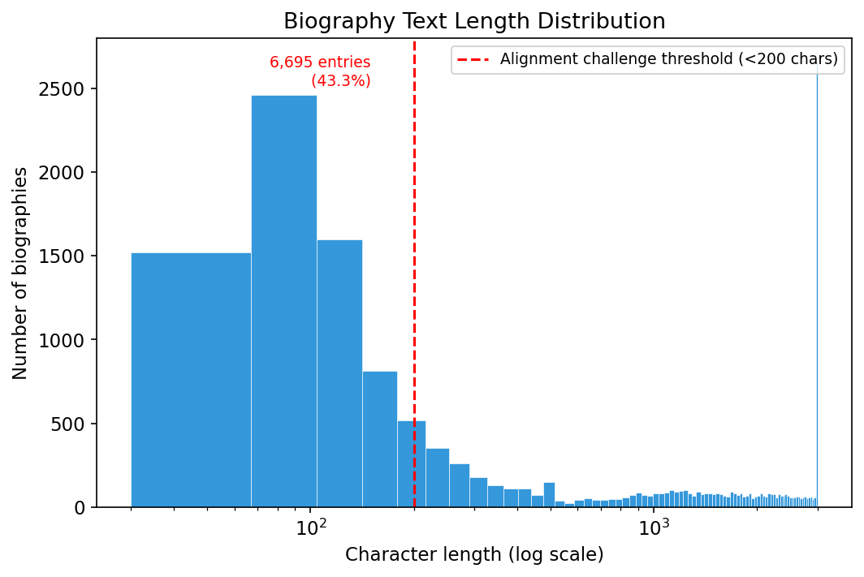
Figure 3.2: Biography Text Length Distribution
- Mean character length: 1,098 | Median: 332
- P10: 68 chars | P90: 3,000 chars
- Interquartile Range (IQR): 2,137 chars (P25 = 103, P75 = 2,240)
- Estimated mean word count: 183 | Median: 55
Critically, 43.3% of entries (6,695 narrators) contain fewer than 200 characters — insufficient textual context for reliable sentiment-based scoring. This data sparsity at the short-entry tail directly explains the high quarantine rate observed during the alignment phase (Section 4.2.2), where length disparities between query texts and encyclopedia entries caused substantial alignment failure. Narrators with short biographies are disproportionately represented among the cold-start population that depends on GNN-based structural inference.
[VIS: Histogram of biography text lengths (characters) with log-scale x-axis and annotation marking the alignment challenge threshold]

3.2.1.3 Alias Density
The alias index contains 24,545 alternative name forms mapped to canonical narrator identities, with an average of 4.02 orthographic variants per canonical narrator (median = 1, max = 1,848 for highly cited figures). Notably, 7.9% of narrators (1,935 individuals) have five or more distinct name forms, and 2.7% (652 narrators) have twenty or more. These variations arise from classical Arabic orthographic conventions, i.e. tashkīl (vocalisation marks), alif variants (alif maqṣūra, alif mamdūda, hamza), and the nisba suffix, all of which cause the same historical figure to appear under substantially different surface forms across Sanadset chain records.
The density of alias forms confirms that a simple string-matching lookup strategy is inadequate for this task and justifies the hybrid two-tier alignment framework (TF-IDF $n$-gram retrieval followed by Levenshtein threshold verification) described in Section 3.3.3.
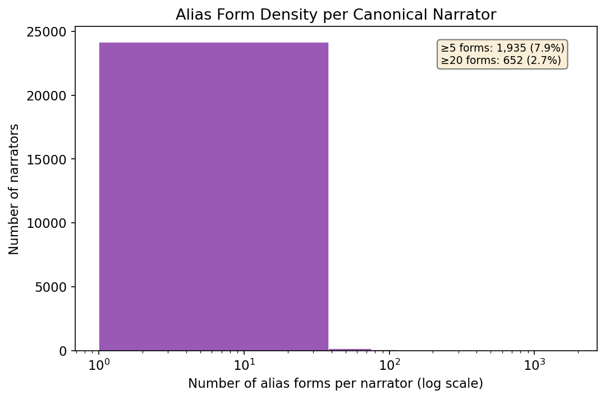
Figure 3.3: Alias Form Density per Canonical Narrator

3.2.2 Graph Topology and Structural Sparsity (KG/GNN Dimension)

3.2.2.1 Scale-Free Power-Law Topology
The Hadith transmission network constructed from the full 650,986-chain Sanadset corpus comprises 262,497 unique narrator nodes connected by 987,036 directed teacher-student transmission edges. The degree distribution computed from the 262,497-node full graph follows a scale-free power law with exponent $γ≈2.15$, consistent with other historical citation networks and real-world social graphs. Within the 2,172-node graded subgraph (the subset of narrators linkable to biographical encyclopedia entries), the degree distribution exhibits a similar heavy-tailed pattern $(γ≈1.61$, mean degree 4.12, median 2, max 291), with the top 1% of nodes accounting for 19.8% of total connection degree.
This topological property has two direct implications for the experimental pipeline. First, the presence of high-degree hub narrators i.e. major compilers and prolific teachers, means that even modest improvements in scoring accuracy for a single hub propagate to hundreds or thousands of downstream chains, amplifying the impact of the GAE structural embeddings. Second, the long tail of low-degree peripheral narrators (each appearing once or twice) constitutes the majority of the cold-start challenge. These are narrators whose reliability cannot be established from local evidence and must instead be inferred from neighbourhood context.
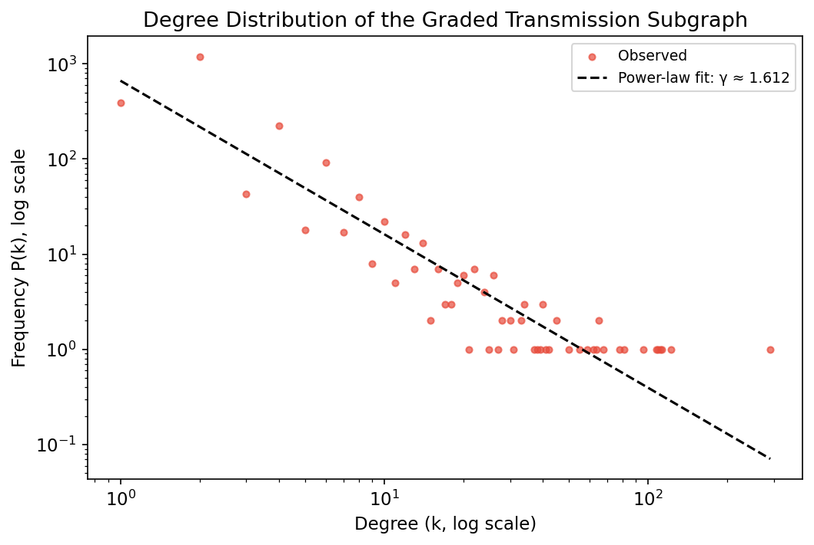
Figure 3.4: Degree Distribution of the Graded Transmission Subgraph
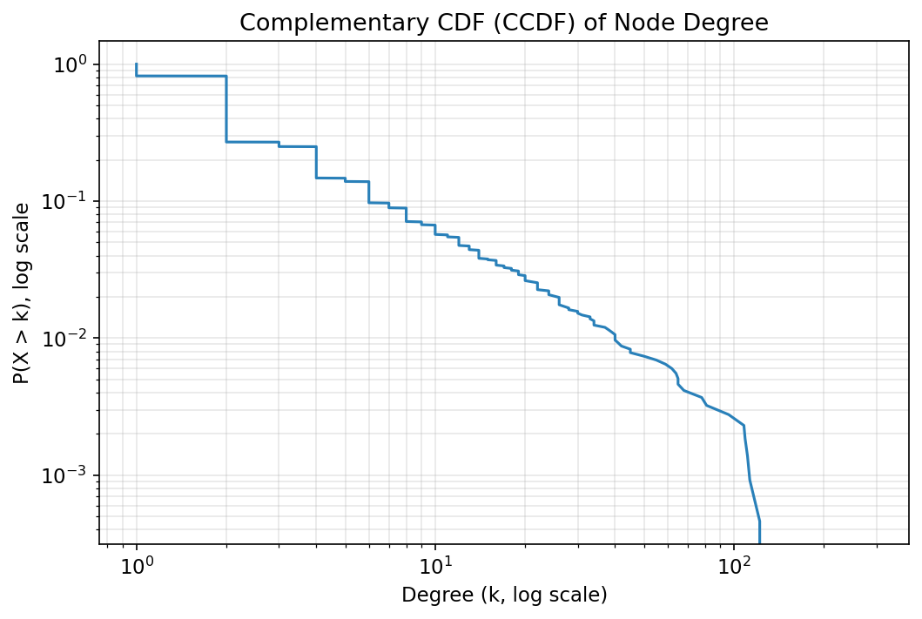
Figure 3.5: Complementary Cumulative Distribution Function (CCDF) of Node Degree

3.2.2.2 The Cold-Start Challenge
Attribute sparsity is the defining structural challenge of this KG. While the full graph contains 262,497 narrator nodes, only 2,172 nodes (0.83%) are linkable to the biographical encyclopaedia and therefore carry explicit grade, tabaqa, or death metadata. Within this graded subgraph, coverage is itself incomplete: 91.48% carry grade labels, 88.17% carry generation (tabaqa) information, and 63.81% record death years, leaving 8.52% of subgraph nodes with none of the three attributes. Extrapolating to the full graph, only 1,987 nodes (0.76% of 262,497) carry an explicit reliability score from the sentiment pipeline, while the remaining 260,325 nodes (99.17%) are structurally cold-start. They exist in the KG as nodes with known neighbours but no intrinsic attribute signal.
This near-total attribute absence is the primary motivation for the Graph Autoencoder (GAE) component described in Section 3.5.2. The GAE learns dense 64-dimensional node embeddings ($Z∈R^{N×64}$) purely from the adjacency structure of the transmission network, enabling the model to propagate reliability signal from the 0.83% of labelled nodes to the unlabelled majority through neighbourhood-based message passing.

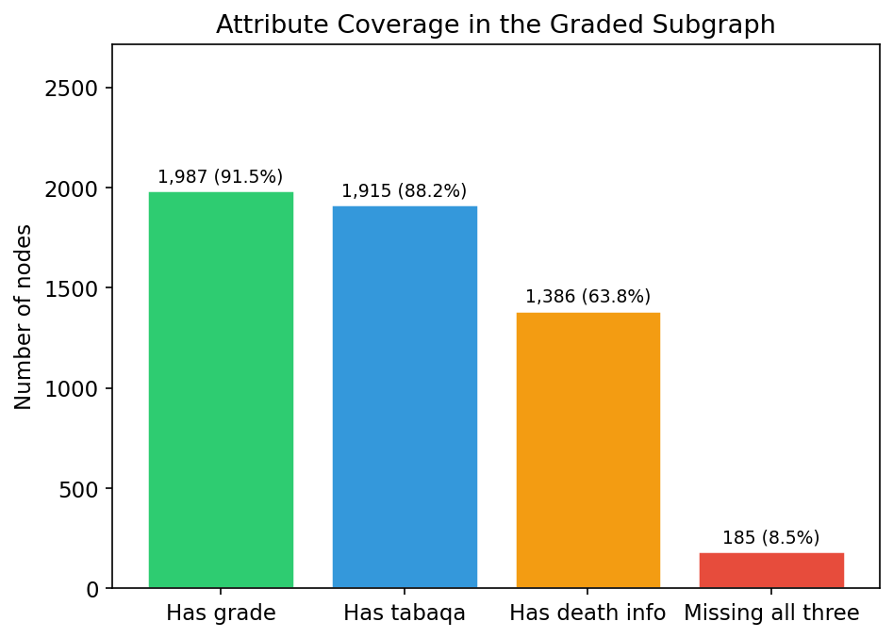
Figure 3.6: Attribute Coverage in the Graded Subgraph

3.2.3 Spatiotemporal Metadata (Domain Dimension)

3.2.3.1 Chronological Distribution Across Generations
The graded subgraph contains 1,915 narrator nodes with extractable generation (tabaqa) information, spanning the classical 11-generation framework from the Companions (Gen 2, ca. 643–664 CE) through the later transmitters (Gen 11, ca. 832–853 CE). The distribution across generations is markedly bimodal, with a pronounced peak in the later periods:
Generation | Approximate Period | Narrators | Percentage
2 | 643 — 664 CE | 48 | 2.5%
3 | 664 — 685 CE | 124 | 6.5%
4 | 685 — 706 CE | 49 | 2.6%
5 | 706 — 727 CE | 56 | 2.9%
6 | 727 — 748 CE | 124 | 6.5%
7 | 748 — 769 CE | 135 | 7.0%
8 | 769 — 790 CE | 76 | 4.0%
9 | 790 — 811 CE | 169 | 8.8%
10 | 811 — 832 CE | 394 | 20.6%
11 | 832 — 853 CE | 592 | 30.9%
The dominance of Generations 10 and 11 (together accounting for 51.5% of all dated narrators) reflects the period of the major Hadith collectors: al-Bukhārī (d. 256 AH/870 CE), Muslim (d. 261 AH/875 CE), Abū Dāwūd (d. 275 AH/889 CE), at-Tirmidhī (d. 279 AH/892 CE), an-Nasāʾī (d. 303 AH/915 CE), and Ibn Mājah (d. 273 AH/887 CE), whose biographical dictionaries provide the densest coverage in the Tahdhīb al-Kamāl source corpus. The absence of Generation 1 data reflects the convention that Tahdhīb al-Kamāl focuses on post-Companion narrators.
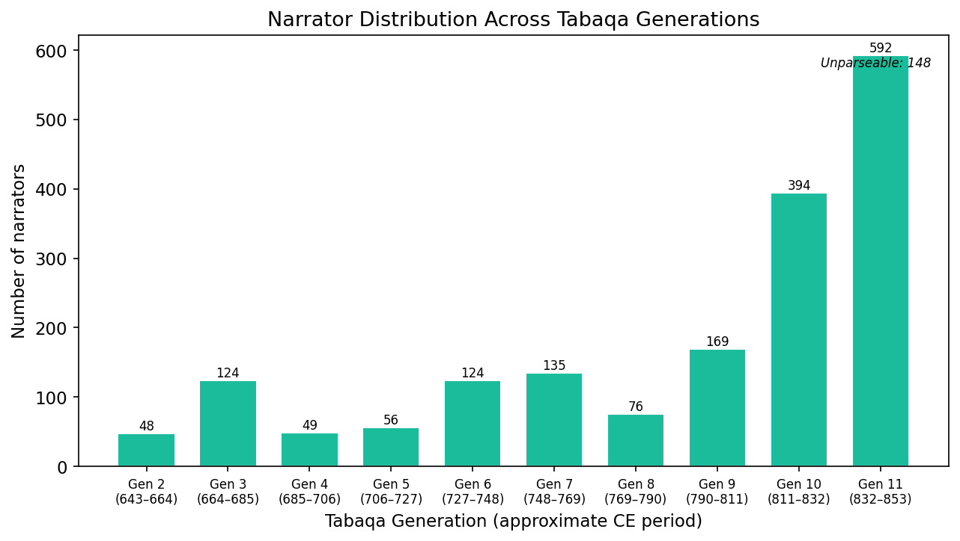
Figure 3.7: Narrator Distribution Across Ṭabaqa Generations
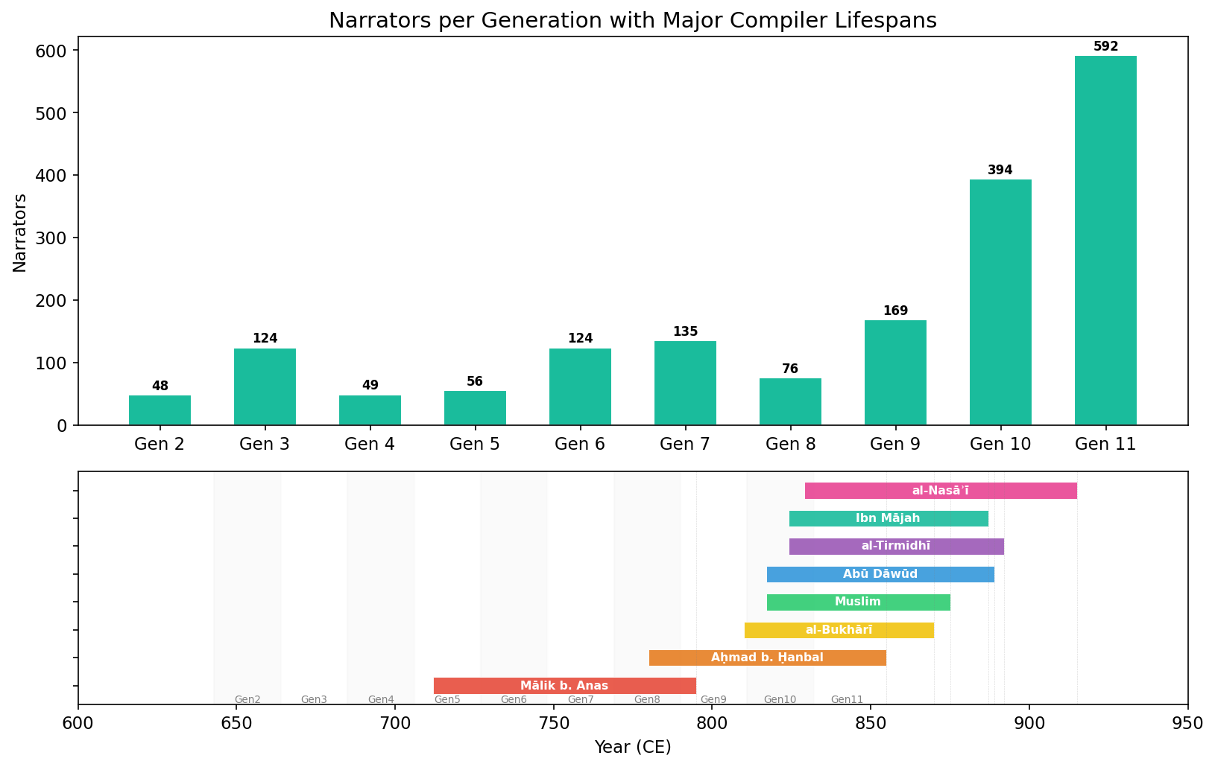
Figure 3.8: Narrators per Generation with Major Compiler Lifespans
[VIS: Timeline with key compiler lifetimes overlaid on generation distribution]

Geographic Concentration
The geo-spatial index maps 5,553 narrator entries to 29 unique municipal locations across 27 distinct coordinate pairs in the classical Islamic world. The geographic distribution is highly concentrated in four metropolitan hubs:
- Kūfa, Iraq: 1,374 entries (24.7%)
- Medina, Hejaz: 1,189 entries (21.4%)
- Basra, Iraq: 983 entries (17.7%)
- Mecca, Hejaz: 274 entries (4.9%)
- Greater Syria (ash-Shām): 226 entries (4.1%)
- Egypt: 195 entries (3.5%)
- Damascus: 194 entries (3.5%)
- Baghdad: 186 entries (3.3%)
- Other centres (Marw, Wāsiṭ, Rayy, Nishapur, Ḥimṣ, al-Jazīrah, Khurāsān, Ḥarrān): 872 entries (15.7%)
The four dominant centres, Kūfa, Medina, Basra, and Mecca, collectively account for 68.7% of all geo-mapped transmitter entries. The geographic distribution reflects the historical reality of early Islamic knowledge transmission: the Hejaz (Medina and Mecca) served as the origin of the prophetic tradition, while the nascent Iraqi metropolises of Kūfa and Basra became the primary centres of Hadith scholarship and legal theory during the 2nd–3rd Islamic centuries. This concentration validates the need for the geospatial penalty mechanism described in Section 3.5.3, as transmitters from disparate geographic regions would have had limited opportunity for direct face-to-face transmission.
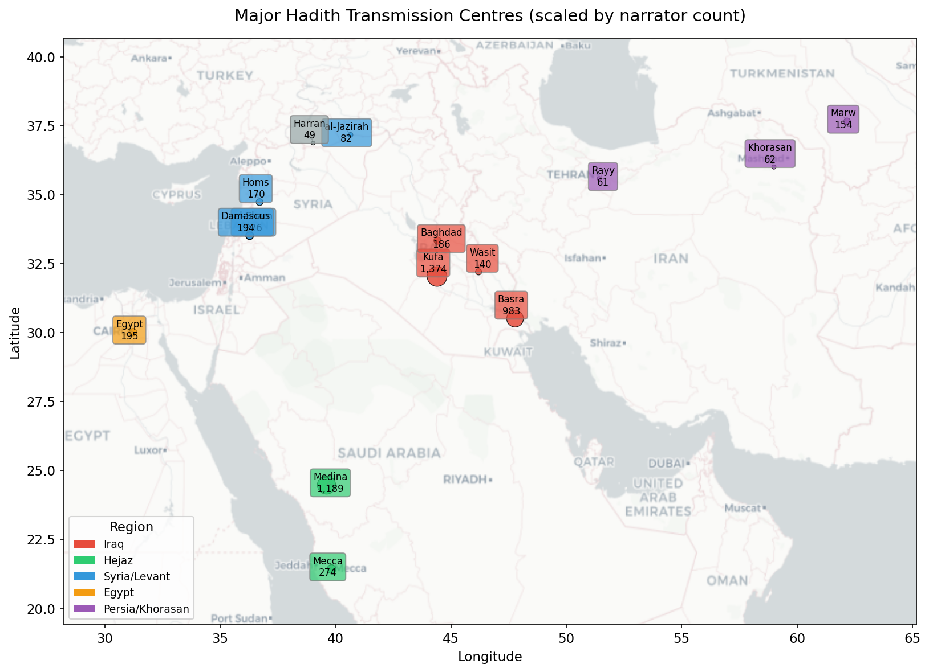
Figure 3.9: Major Hadith Transmission Centres (scaled by narrator count)
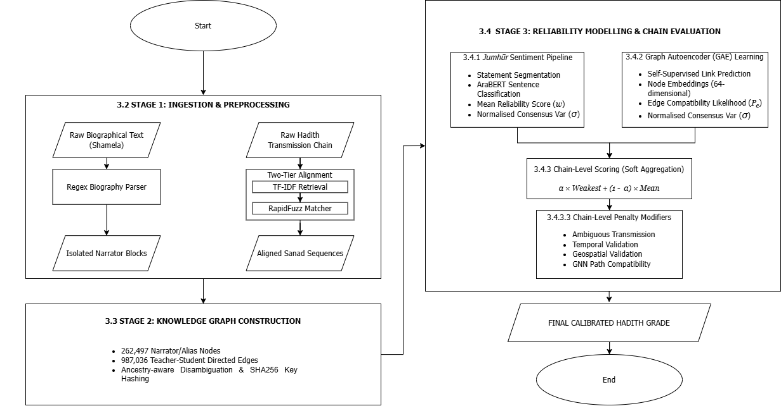
Figure 3.10: Flowchart of the Multi-Modal Hadith Authenticity Verification Pipeline

3.2 Stage 1: Data Ingestion and Preprocessing

3.2.1 Data Sources
The framework integrates structured transmission data with unstructured biographical judgments:
- Biographical Corpora: Sourced from the Shamela Digital Library, targeting Ibn Hajar al-Asqalani's Taqrīb al-Tahdhīb and al-Mizzi's Tahdhīb al-Kamāl. These serve as the basis for extracting consensus textual judgments.
- Transmission Corpora: To ensure target alignment goals are approached despite Tier 2 Levenshtein quarantine filtering, maximum pre-alignment sampling thresholds of up to 1,800 and 7,000 query Hadiths are drawn from Hugging Face datasets with canonical grades (e.g., Ṣaḥīḥ, Ḍaʿīf, Ḥasan). The final achieved sample sizes are dynamically constrained by the baseline corpus availability across balancing strategies.

3.2.2 Biographical Text Parsing and Block Extraction
Raw texts are pre-processed using a custom Regular Expression (Regex) parser. The parser identifies structured markup (e.g., # $Tarjama tags) and entry delimiters, isolating independent text blocks for each narrator. It filters out metadata headers, page numbers, and publisher footnotes to yield clean, consonantal Arabic skeletons for analysis.

3.2.3 Two-Tiered Algorithmic Alignment Framework
To link transmission chains to biographical entries without a shared index, the system implements a two-tiered alignment pipeline:
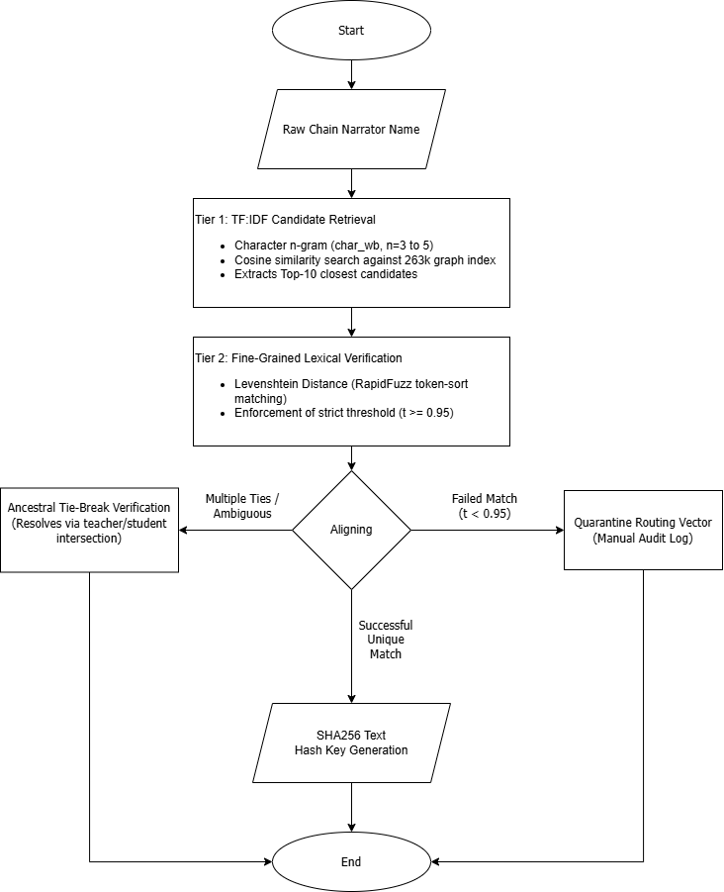
Figure 3.2: Two-Tiered Algorithmic Alignment Architecture
- Tier 1: Heuristic Search Space Reduction (Information Retrieval Layer): Computes TF-IDF vectors using character-level $n$-grams ($n∈\left[3,5\right]$) on normalised text. This isolates a candidate pool of the top 10 matches for any input query out of the 262k entries, bypassing computational bottlenecks.
- Tier 2: Fine-Grained Lexical Verification (Fuzzy Matching Layer): Applies token-sort Levenshtein distance calculations via the RapidFuzz library to select the optimal candidate. Matches must exceed a strict similarity threshold ($t≥0.95$).
- Ancestral Node Tie-Breaking: When multiple candidates yield identical fuzzy ratios, the algorithm resolves the tie-break by checking the immediate predecessor and successor nodes (the narrator's teachers and students) against the biographical network.
- SHA256 Identity Preservation: Aligned entities are assigned an immutable, unique primary key calculated as a SHA-256 hash of their normalised Arabic consonantal skeleton.
- Quarantine Routing: Records failing to meet the fuzzy matching threshold or showing irreconcilable network overlaps are routed to a JSON quarantine log for manual scholar-in-the-loop audit.

3.3 Stage 2: Knowledge Graph Construction

3.3.1 Relational Graph Dimensions
Rather than utilising a small sample, the system builds a comprehensive Knowledge Graph (KG) mapping the historical transmission network. The dimensions of the constructed graph are detailed in Table 3.1.
Table 3.1: Dimensions of the Constructed Relational Knowledge Graph
Graph Entity / Relation | Actual Count
Total Graph Nodes | 262,497
Total Graph Edges | 987,036
Narrator Encyclopaedia Entries | 15,448
Alternative Aliases | 24,545
Inter-Narrator Family Links | 13,592

3.3.2 Node & Edge Attribute Representation
Each narrator node is populated with rich attributes extracted from classical literature:
- Tabaqa (Generation): Coded as an integer range from 1 to 12 matching Ibn Hajar's temporal classification (ranging from the Ṣaḥāba [Companions, ~1st Century AH] to late compilers [~3rd Century AH]).
- Geographic Travel Regions: Categorised lists of historically visited cities (e.g., Medina, Kufa, Basra, Damascus, Baghdad, Cordoba).
- Relational Edges: Directed connections mapping teacher-to-student propagation ($u→v$).

3.3.3 Algorithmic Name Mapping (Alias & Ancestry Matcher)
Due to the absence of trained Named Entity Recognition (NER) models with verified entity-level F1 metrics in this domain, narrator boundary parsing is executed via heuristic token extraction, index matching, and alias resolution. This maps narrator chains directly to the canonical node database. Token classification via fine-tuned Transformer-based NER models (AraBERT sequence labelling) is demoted to future work.

3.4 Stage 3: Probabilistic Trust Scoring and Evaluation

3.4.1 Semantic Sentiment Analysis for Continuous Reliability Scoring
Instead of assigning binary weights, the framework implements a multi-tiered Jumhūr Sentiment Aggregation pipeline to estimate narrator reliability. This models the differences of opinion among classical critics (Jumhūr or consensus) as a continuous scoring task.
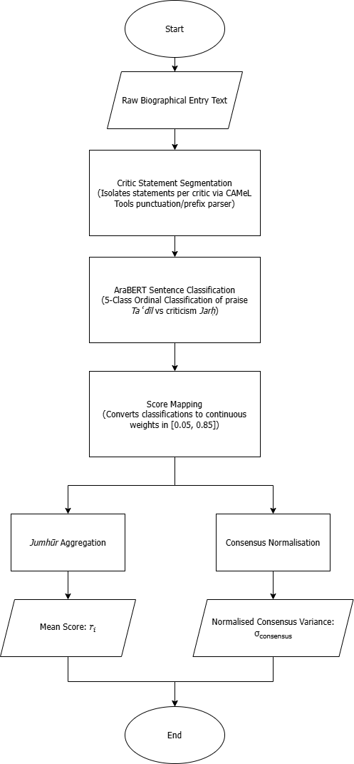
Figure 3.3: Multi-Tiered Jumhūr Sentiment Aggregation Pipeline
- Critic Statement Segmentation: Extracts individual evaluative statements using Arabic punctuation patterns and scholar-specific prefix indicators (e.g., قال أحمد, “Ahmad said”).
- AraBERT Sentence-Level Classification: Predicts the sentiment of each statement using an AraBERT-based classifier pre-trained on Arabic sentiment data. To model narrator reliability from evaluative biographical statements, the system formulates the task as discrete ordinal classification rather than direct continuous regression. In qualitative NLP tasks, a common limitation known as Deep Imbalanced Regression (DIR) is where continuous regression objectives frequently suffer from severe score compression and regression toward the empirical mean when predicting unbounded numerical values across skewed qualitative classes (Yang et al., 2021). By formulating the task as a 5-class ordinal classification problem (matrūk, ḍaʿīf, maqbūl, ṣadūq, thiqa), the architecture enforces crisp decision boundaries between quality bands before mapping predictions to continuous ordinal score weights [0.05, 0.85].
- Score Mapping: Translates raw sentiment predictions into ordinal class scores ranging from 0.05 (severely weak / matrūk) to 0.85 (highly reliable / thiqa). This ceiling of 0.85 represents the inherent historical uncertainty of human transmission; classical Hadith criticism is fundamentally a via negativa process focusing on defect detection, meaning no narrator is modeled with absolute mathematical certainty (1.0). Ultra-high terms (Thābit, Ḥāfiẓ, Imām) under Class 4 and severe defects (Waddāʿ, Dajjāl) under Class 0 are grouped to prevent the AraBERT model from suffering from data sparsity issues. The mapping of qualitative scholarly judgments to numerical values and their classical Arabic synonyms is detailed in Table 3.2:

Table 3.2: Semantic Score Mapping and Classical Arabic Synonyms for Biographical Tiers
Model Quality Tier | Classical Arabic Grade Synonyms | Sentiment Polarity | Numeric Score Mapping ($s_{i}$) | Academic Explanation
Thiqa (Class 4) | ثقة, ثقة ثقة, ثقة ثبت, ثقة حافظ, ثقة متقن, ثبت, حافظ, إمام, مأمون, صحابي | Taʿdīl (Praise) | $$0.85$$ | Maximum reliability tier for the textual semantic layer.
Ṣadūq (Class 3) | صدوق, لا بأس به, ليس به بأس, محله الصدق | Taʿdīl (Praise) | $$0.70$$ | Truthful narrator but susceptible to minor errors.
Maqbūl (Class 2) | مقبول, صدوق يهم, صدوق سيء الحفظ, سيء الحفظ | Marginal / Neutral | $$0.40$$ | Acceptable only when supported by corroborating chains.
Ḍaʿīf (Class 1) | ضعيف, ضعيف الحديث, لين, لين الحديث, ليس بالقوي, فيه ضعف, مستور, مجهول الحال | Jarḥ (Criticism) | $$0.15$$ | Unreliable or weak narrator.
Matrūk (Class 0) | متروك, متروك الحديث, ساقط, مختلط, مجهول العين, كذاب, وضاع, دجال | Jarḥ (Criticism) | $$0.05$$ | Abandoned narrator (minimum baseline boundary).

- Jumhūr Aggregation: Computes the narrator's base semantic reliability score ($r_{i}$) as the mean of their individual statement scores:
$$r_{i}=\frac{1}{N}\sum_{j=1}^{N}{s_{j}}$$
- Consensus Score Calculation: Measures the variance of opinions for each narrator. To represent scholarly agreement on a normalised scale, the consensus score is calculated as:
$$\text{agreement_score}=1.0-\frac{\text{Var}\left(s\right)}{0.16}$$
Where the denominator ($0.16$) represents the maximum possible variance of a continuous score bounded on the interval $\left[0.05,0.85\right]$. The maximum variance occurs at a 50/50 split at the boundaries:
$${\text{Var}}_{max}={\left(\frac{0.85-0.05}{2}\right)}^{2}={\left(0.40\right)}^{2}=0.16$$

3.4.2 Unsupervised Graph Autoencoders (GAE) for Structural Representation Learning
Instead of attempting to predict narrator grades directly from a supervised GNN (which suffers from label scarcity and introduces bias), the structural analysis component uses an unsupervised Graph Autoencoder (GAE).

3.4.2.1 GAE Architecture
The GAE encodes node structures into a latent space and reconstructs network topology using a link prediction objective:
- Encoder: A 2-layer Graph Convolutional Network (GCN) that takes node feature vectors $X$ and the adjacency matrix $A$ to compute 64-dimensional latent embeddings $Z$:
$$Z=\text{GCN}\left(X,A\right)$$
- Decoder: A simple inner product that reconstructs the link compatibility score ($P_{e}$) for any edge $\left(u,v\right)$:
$${\overset{ˆ}{A}}_{u,v}=σ\left(z_{u}^{T}z_{v}\right)$$
- Objective Function: The reconstruction loss is defined as binary cross-entropy on link existence:
$$L=-\sum_{\left(u,v\right)∈E}{\log\left(σ\left(z_{u}^{T}z_{v}\right)-\sum_{\left(u,v\right)∉E}{\log\left(1-σ\left(z_{u}^{T}z_{v}\right)\right)}\right)}$$
The GAE is trained for 200 epochs using the Adam optimiser (learning rate = $1×{10}^{-3}$, dropout = $0.3$). The model achieves robust link prediction performance on a 20% test split:
- ROC-AUC: 92.39%
- Average Precision (AP): 94.04%

3.4.2.2 GNN Uncertainty Modulation
The GNN embeddings modulate the narrator reliability score rather than overriding textual criticism. For a narrator with a marginal base score, the system checks their structural embedding. If the narrator exhibits high link compatibility ($P_{e}≥0.50$) and is well-integrated within reliable transmission paths, a GNN mitigation factor is applied to reduce their base weakness penalty by up to a maximum of 15%:
$$\text{effective_penalty}=\text{base_penalty}×\left(1-\text{GNN_mitigation}\right)$$

3.4.3 Chain-Level Scoring (Soft Aggregation)
The final authenticity score of a Hadith transmission chain ($S_{chain}$) is computed by combining modulated individual narrator reliability scores using a soft aggregation function, which is then adjusted by topological, geospatial, and temporal penalty modifiers.
For each narrator $i$ in a transmission chain of length $M$, the system first computes an individual modulated score $W_{i}$:
$$W_{i}=w_{i}×{\text{risk}}_{i}$$
where ${\text{risk}}_{i}∈\left[0.0,1.0\right]$represents narrator-specific risk modifiers. To extract these modifiers, a rule-based linguistic pattern-matching pipeline scans the normalised biographical text during the data preparation stage for classical Arabic root patterns representing specific transmission defects:

Table 3.3: Risk Modifier Multipliers with Description
Risk Modifier Type | Arabic Lexical Patterns | Multiplier | Technical Description
Concealed Weakness (tadlīs) | تدليس, مدلس, يدلس | $$0.80$$ | Narrator conceals their immediate teacher's identity using ambiguous terms.
Mental Deterioration (ikhtilāṭ) | مختلط, اختلط بآخره, تغير بآخره, تغير قبل | $$0.50$$ | Narrator suffered memory loss or cognitive decline in later life.
Identity Uncertainty (jahāla) | مجهول العين, مجهول الحال | $$0.30$$ | Narrator's status or reliability is unknown to biography compilers.
Fabrication (kadhib) | كذاب, يضع الحديث, وضاع, متهم بالكذب | $$0.00$$ | Narrator is accused of lying or deliberate fabrication (chain-breaking).
If a narrator's biography contains multiple defects, the system selects the most severe penalty by calculating the minimum modifier:
$${\text{risk}}_{i}=\min_{k}\left({\text{modifier}}_{k}\right)$$
If no defects are detected, the modifier defaults to ${\text{risk}}_{i}=1.0$.
The base narrator score $w_{i}$ combines their semantic reliability score $r_{i}$ with severity-band and consensus modulations:
$$w_{i}=r_{i}×d_{i}×d_{agree,i}$$
The variables in this calculation are defined as follows:
- Severity-Band Discount ($d_{i}$): Base discount factor mapped to narrator reliability ranges:
$$d_{i}=\left\{\begin{matrix}1.0 & \text{if }r_{i}≥0.80\text{ (}\text{Thiqa}\text{)} \\ 1.0 & \text{if }r_{i}≥0.70\text{ (}\text{Ṣadūq} \text{)} \\ 0.85 & \text{if }r_{i}≥0.40\text{ (}\text{Maqbūl} \text{)} \\ 0.60 & \text{if }r_{i}≥0.20\text{ (}\text{Ḍaʿīf} \text{)} \\ 0.25 & \text{if }r_{i}<0.20\text{ (}\text{Matrūk}\text{)}\end{matrix}\right.$$
- GNN Uncertainty Modulation: If a narrator falls into a Maqbūl or Ḍaʿīf category, but exhibits high structural integration in the GAE Knowledge Graph (indicated by a low GNN Anomaly Score $A_{i}<0.25$), a structural mitigation factor is applied to the discount:
$$d_{i}^{mitigated}=d_{i}+\left(1.0-d_{i}\right)×0.15$$
- Disagreement Risk Modifier ($d_{agree,i}$): Penalises narrators with high scholarly disputes (low consensus scores):
$$d_{agree,i}=1.0-0.20×\left(1.0-{\text{agreement_score}}_{i}\right)$$
where ${\text{agreement_score}}_{i}=1.0-\frac{\text{Var}\left(s\right)}{0.16}$ represents the consensus rating.

3.4.3.2 Base Chain Score ($S_{base}$)
Rather than multiplying narrator scores ($S_{chain}=\prod{W_{i}}$), which causes exponential score decay on longer chains, the pipeline uses a parameterised Soft Aggregation formula:
$$S_{base}=α×\min_{i}\left(W_{i}\right)+\left(1-α\right)×\left(\frac{1}{M}\sum_{i=1}^{M}{W_{i}}\right)$$
where $α∈\left\{0.25,0.50,0.75\right\}$ is empirically optimised to balance the weakest-narrator bottleneck with overall chain quality.

3.4.3.3 Chain-Level Penalty Modifiers
The base chain score is adjusted by multiplying three independent penalty factors:
- Ambiguous Transmission (ʿAnʿana) Penalty ($P_{amb}$): Applied if a narrator categorised as a Mudallis (known to practice tadlīs) transmits using the ambiguous particle عن (ʿan, “from”) instead of explicit direct audition (e.g., حدثنا, haddathana, “we narrated”).
- Temporal Validation (Inqitāʿ) Penalty ($P_{temp}$): Evaluates chronological feasibility between adjacent narrator generations (tabaqāt). If a teacher is younger than the student (chronological impossibility) or exhibits significant gaps, a broken transmission (inqitāʿ) is flagged:
$$P_{temp}=\left\{\begin{matrix}0.40 & \text{if severe gap (e.g., teacher }≥\text{ student }+5\text{ generations)} \\ 0.60 & \text{if moderate gap (e.g., teacher }≥\text{ student }+3\text{ generations)} \\ 1.0 & \text{otherwise}\end{matrix}\right.$$
- Geospatial Validation Penalty ($P_{geo}$): Compares travel paths between adjacent transmitters. If lifespans overlap but travel records show no plausible geographic intersection (distance between locations $>3,000$km), a distance penalty is applied:
$$P_{geo}=\prod_{j=1}^{M-1}{g_{j}}, \text{where }g_{j}=\left\{\begin{matrix}0.85 & \text{if distance }>3,000\text{ km} \\ 1.0 & \text{otherwise}\end{matrix}\right.$$
- GNN Path Compatibility Penalty ($P_{gnn}$): Uses the GAE link prediction scores to check structural continuity between adjacent nodes in the chain:
$$P_{gnn}=\left\{\begin{matrix}0.85 & \text{if }\min_{j}\left(σ\left(z_{j}^{T}z_{j+1}\right))<0.25\right) \\ 1.0 & \text{otherwise}\end{matrix}\right.$$

3.4.3.4 Final Chain Score ($S_{chain}$)
The final authenticated score is the product of the soft-aggregated base score and the edge penalty modifiers:
$$S_{chain}=S_{base}×P_{amb}×P_{temp}×P_{geo}×P_{gnn}$$
This continuous score is subsequently mapped to canonical grades (Ṣaḥīḥ, Ḥasan, Maqbul, Ḍaʿīf, Matrūk) using calibrated percentile thresholds.

3.4.4 Evaluation Protocol
The pipeline's grading accuracy is validated against classical Hadith classifications across multiple datasets at the following scales:
- 1,200 Aligned Benchmarks: Evaluated across Book-Balanced (300 per collection) and Grade-Balanced parameters using fixed pre-alignment sampling targets of 1,800 query Hadiths.
- 6,000 Aligned Benchmarks: Evaluated across Book-Balanced (~1,166 per collection) and Grade-Balanced parameters using fixed pre-alignment sampling targets of up to 7,000 query Hadiths (utilising all available graded records for grade-balanced sets).
- 435,000 Bulk Grading: Scale testing performed on 435,351 valid chains from the Sanadset corpus to analyze the overall score distribution.
The model maps the final continuous chain score to five ordinal classes: Ṣaḥīḥ (Authentic), Ḥasan (Good), Maqbul (Acceptable), Ḍaʿīf (Weak), and Matrūk (Abandoned). Threshold calibration is performed using percentile-matching rather than standard regression to prevent threshold collapse.

3.5 Milestones and Dates
The following table shows the weekly milestones with their deliverable respectively:
Table 6: Milestones and Deliverables by Week
Week | Milestone | Deliverable
2-2025/2026
1-2 | Project Initialisation | Finalised project summary; supervisor approval
3-4 | Literature Review | Completed Chapter 2; dataset acquisition
5-6 | Methodology Design | Completed Chapter 3; proposal draft
7 | Proposal Defence | Oral defence and proposal submission
8-9 | Stage 1 Implementation | Cleaned corpus; preprocessed JSON dataset
10-11 | Stage 2 Implementation | Trained NER model; populated Knowledge Graph
1-2026/2027
1-2 | Stage 3 Implementation | Trust scoring module; preliminary evaluation results
3-4 | Thesis Report Preparation | Written report drafting
5-6 | Thesis Presentation Preparation | Final thesis presentation drafting

3.6 Gantt Chart
Year | 2026 |  |  |  |  |  |  |  |  |  | 2027
Project Activities | Mar | Apr | May | Jun | Jul | Aug | Sep | Oct | Nov | Dec | Jan | Feb
Title Selection
One-Paged Summary Submission
Preparation of Proposal
Proposal Submission
Proposal Defence
Stage 1: Data Ingestion and Preprocessing
Dataset Acquisition
Preprocessing Pipeline
Stage 2: Named Entity Recognition and Knowledge Graph Construction
AraBERT Fine Tuning (NER)
Knowledge Graph Construction
Stage 3: Probabilistic Trust Scoring and Evaluation
Sentiment Quantisation Module
Chain Scoring & Evaluation
Reporting
Thesis Preparation
Thesis Presentation Preparation
Thesis Submission
Thesis Presentation (VIVA)

3.7 Tools and Technologies
Below are the tools, libraries and technologies used to build this project, along with their purpose for the project:
Table 7: Tools, Libraries, and their Purposes by Category
Category | Tool/Library | Purpose
Language | Python 3.10+ | Primary development language
NLP Preprocessing | CAMeL Tools, PyArabic, Farasa | Arabic normalisation, tokenisation, segmentation
Transformer Model | AraBERT v2 (HuggingFace) | Fine-tuned NER for narrator extraction
Deep Learning | PyTorch, Transformers (HuggingFace) | Model training and inference
Graph Processing | NetworkX/Neo4j | Knowledge Graph construction and querying
Geocoding | Geopy | To convert classical Arabic place names (nisba) into latitude/longitude.
Mapping | Folium | To generate static maps showing the “geographical journey” of a Hadith.
Evaluation | scikit-learn | Classification metrics (F1, Precision, Recall, Kappa)
Data Format | JSON, CSV | Structured intermediate data storage
Version Control | Git/GitHub | Source code and experiment tracking
Documentation | Google Docs, Markdown, LaTeX | Proposal and report writing

CHAPTER 4

EXPERIMENT DESIGN

This chapter presents the experimental design constructed to validate the three research objectives of this project: (PO1) developing an NLP-based qualitative-to-quantitative reliability scoring model, (PO2) constructing a multi-relational Knowledge Graph with Graph Autoencoder (GAE) structural representation learning, and (PO3) evaluating the resulting pipeline against canonical Hadith gradings.
The experiments are organised chronologically across the three processing stages of the pipeline: (1) Data Ingestion and Preprocessing, (2) Knowledge Graph Construction and Node Alignment, and (3) Probabilistic Trust Scoring, Graph Neural Network (GNN) learning, and Chain-Level Soft Aggregation.

4.1 Research Methodology and Environment
All experimental tasks were conducted in a standardised local development environment to ensure strict reproducibility:
- Hardware Configuration: Local workstation equipped with an Intel Core i7-10750H CPU, 16 GB of DDR4 RAM, and an NVIDIA GeForce RTX 2070 Max-Q GPU (8 GB VRAM) for accelerating transformer inference and Graph Neural Network training.
- Software Configuration: The pipeline is implemented in Python (v3.13) utilising PyTorch (v2.3) and PyTorch Geometric (v2.5) for GNN operations, NetworkX (v3.2) for Graph construction, CAMeL-Tools (v1.2.0) and transformers (v4.40) for Arabic sentence classification, and pandas (v2.2) and numpy (v1.26) for vector operations.

4.2 Exploratory Data Analysis
Before executing the experimental pipeline, an exploratory data analysis was conducted to understand the statistical properties of the primary datasets. This analysis informs parameter choices and provides context for interpreting experimental outcomes.

4.2.1 Sanadset 650K Corpus
The primary transmission corpus contains 650,986 Hadith chains spanning 956 distinct book references. Chain lengths follow a right-skewed distribution with a median of 5 narrators per chain (mean = 4.63, P90 = 9, P99 = 18). The corpus contains 263,829 unique narrator name forms, with narrator appearances following a power-law distribution characteristic of historical citation networks: the median narrator appears only once, while the most frequent narrator appears over 63,000 times.

4.2.2 Kutub as-Sitta Ground-Truth Corpus
The annotated evaluation corpus comprises 33,738 Hadiths across the six canonical collections. The grade distribution is heavily skewed toward Ṣaḥīḥ (36.3%), followed by Ḥasan (8.4%), with Ḍaʿīf and Matrūk grades together representing less than 0.1% of entries. This extreme class imbalance motivates the use of both book-balanced and grade-balanced sampling strategies in the experimental design (Section 4.3.2), as raw accuracy would be misleadingly high if evaluated on the natural distribution alone.

4.2.3 Biographical Encyclopaedia
- The Shamela-derived biographical encyclopedia contains 15,448 narrator entries extracted from *Tahdhīb al-Kamāl* (35 volumes) and *Taqrīb at-Tahdhīb* (1 volume). Of these, 10,920 entries (70.7%) carry explicit *Jarḥ* wa *Taʿdīl* grades, with the most frequent grade classifications being *Thiqah* (3,150), *Ṣadūq* (2,495), and *Maqbūl* (2,088). Additionally, 6,673 entries (43.2%) contain generation (*tabaqa*) information, 2,321 entries (15.0%) record death years, and 7,319 entries (47.4%) list teacher-student relationships.

- ### 4.2.4 Sentiment Score Distribution

- Applying the Jumhūr sentiment pipeline (Section 3.4.1) to the encyclopedia yields scores for 262,497 knowledge graph nodes. Critically, only 8,995 narrators (3.43%) have explicit textual criticism evidence — the remaining 253,502 nodes (96.57%) receive the GNN-based default fallback score. The reliability distribution is compressed toward the upper band: 99.05% of narrators score at or above the *Maqbūl* threshold (0.40), reflecting the historically reliable nature of the transmission network.

- ### 4.2.5 Knowledge Graph Topology

- The constructed knowledge graph exhibits a scale-free degree distribution ($\gamma \approx 2.15$), consistent with other historical citation networks. The graph contains 262,497 nodes and 987,036 directed transmission edges. The most highly-connected narrators account for over 22% of all appearances, confirming the presence of influential hub figures in the transmission network.

4.2 Stage 1: Data Ingestion and Preprocessing Experiments
The first experimental stage focuses on clean block extraction and vector-space record alignment to build the foundational data matrix.

4.2.1 Experiment 1: Biographical Text Parsing
- Objective: To evaluate the regular expression (Regex) parser's ability to cleanly segment raw, Shamela-formatted classical Arabic biographical volumes into isolated narrator files.
- Design: The parsing script (run_shamela_extract.py and run_shamela_target_extract.py) scans Maktaba Shamela raw text files. It strips editorial headers, footers, and page numbers, and then isolates narrator text blocks (tarājim) based on structural pattern boundaries (such as numeral prefixes or # $Tarjama tags).
- Parameters:
- Raw Input: 35 volumes of Tahdhīb al-Kamāl and 1 volume of Taqrīb at-Tahdhīb.
- Regex Boundary Matchers: Coded matching patterns targeting entry markers (e.g. ^[\d٠-٩]{1,4}\s*[-–—]).
- Expected Output: A structured JSON narrator encyclopaedia containing 15,448 segmented biography files, with fields for name, full text, listed teachers, listed students, and listed historical grades. The target is an extraction confidence rate of $≥90\%.$

4.2.2 Experiment 2: Two-Tier Alignment Framework
- Objective: To evaluate the accuracy of the record-linking pipeline in cross-referencing Hadith reports between the unstructured Sanadset corpus and the annotated Hadith evaluation corpora.
- Design: The alignment script (run_stage1.py) runs the hybrid indexing model:
- Tier 1 (IR Layer): Character $n$-gram TF-IDF ($n∈\left[3,5\right]$) similarity retrieval extracts the top 10 candidates.
- Tier 2 (Fuzzy Verification): Enforces a strict Levenshtein distance threshold ($t≥0.95$) using the RapidFuzz library to confirm matches.
- Parameters:
- Four Evaluation Dataset Parameters with Fixed Pre-Alignment Sampling Strategy: The benchmarks set target goals of 1,200 and 6,000 successfully aligned Hadith chains across two balancing strategies (Book-Balanced and Grade-Balanced). To ensure target alignment goals are approached despite Tier 2 Levenshtein quarantine filtering ($t≥0.95$), fixed pre-alignment sampling targets of 1,800 and 7,000 query Hadiths are drawn:
- 1,200 Book-Balanced Parameter: 1,800 query Hadiths sampled uniformly across the six canonical books (300 per book) before alignment.
- 1,200 Grade-Balanced Parameter: Up to 1,800 query Hadiths sampled across canonical grade categories (up to 450 per grade, with the actual count constrained by available graded entries) before alignment.
- 6,000 Book-Balanced Parameter: 7,000 query Hadiths sampled uniformly across the six canonical books (~1,166 per book) before alignment.
- 6,000 Grade-Balanced Parameter: Up to 7,000 query Hadiths sampled across canonical grade categories, with the actual count constrained by the number of available graded entries across each grade category before alignment.
- Seed: Global seed fixed to 42 to preserve sample selection.
- Expected Output: Aligned datasets mapping each query Hadith to its counterpart index in the 650K Sanadset corpus, with failed matches (t < 0.95) automatically routed to a JSON quarantine log.

4.3 Stage 2: Entity Linking and Graph Construction Experiments
This stage evaluates the classification of narrator reliability, mapping of text name mentions to canonical network entities, and topological Knowledge Graph construction.

4.3.1 Experiment 3: Narrator Reliability Classification
- Objective: To test the efficacy of fine-tuning an AraBERT v2 transformer model as a 5-class ordinal classifier to categorise narrators into quality tiers (matrūk, ḍaʿīf, maqbūl, ṣadūq, thiqa), comparing its performance directly against a continuous regression baseline to evaluate mitigation of score compression.
- Design: The model fine-tuning script (train_arabert_classifier.py) processes 10,913 narrator profiles containing explicit classical grades. The training dataset is balanced across classes (5,580 training entry-grade pairs, with 1,636 held-out test pairs). The experimental design evaluates two distinct model formulations on identical test splits:
- Continuous Regression Baseline: Trained with a Mean Squared Error (MSE) loss objective predicting continuous reliability scalar values.
- Proposed 5-Class Ordinal Classifier: Trained with a Cross-Entropy loss objective with inverse-frequency class weighting across the five discrete quality tiers.
- Parameters:
- Model Backbone: aubmindlab/bert-base-arabertv2.
- Batch Size: 16; Learning Rate: 2 \times 10^{-5}; Epochs: 4.
- Classes: matrūk (0), ḍaʿīf (1), maqbūl (2), ṣadūq (3), thiqa (4).
- Expected Output: Evaluation metrics on the held-out test split documenting Precision, Recall, Macro F1-Score, and Quadratic Weighted Cohen's \kappa. The target is demonstrating that 5-class ordinal classification significantly mitigates score compression toward the mean compared to continuous regression (target: Macro F1 $≥0.80$, Cohen's $κ≥0.80$).

4.3.2 Experiment 4: Narrator Disambiguation and Name Matching
- Objective: To test the coverage and accuracy of resolving variations in transmitter name spellings against the canonical narrator encyclopaedia index.
- Design: Mentions extracted from the transmission chains are normalised by stripping vocalisation marks (tashkīl), standardising alif variants, and standardising yā and hā spellings. Lookups are executed against the alias index (alias_index.json). If exact matching fails, fuzzy lookup is applied using the RapidFuzz token-sort ratio with a threshold of $0.80$.
- Parameters:
- Input Names: Distinct name strings extracted from the aligned transmission chains.
- Verification check: Cross-referencing immediate predecessors/successors (teachers and students) to resolve ties.
- Expected Output: A JSON name matching log (narrator_matches.json) categorising matches as exact, fuzzy, or quarantined. The target is an overall name resolution rate of $≥80\%$, with matched entries mapped to their canonical biographies.

4.3.3 Experiment 5: Knowledge Graph Construction and Topology
- Objective: To construct a unified, multi-relational Knowledge Graph of the classical Islamic transmission network and evaluate the impact of scale scaling on global topological properties.
- Design: The graph builder walks through transmission records, creating nodes for unique narrators and directed edges ($u→v$) representing teacher-student propagation. A separate sweep integrates alternative alias names and family ties. Each node is annotated with temporal generations (tabaqāt, coded 1 to 12) and travel history metadata. The experiment evaluates graph construction across two distinct corpus scale parameters to measure structural density expansion.
- Parameters:
- Corpus Scale Parameters:
- Subset Graph Scale (100K Rows): Built upon a 100,000-row sample of the Sanadset corpus to observe topological properties at a smaller scale.
- Full-Scale Graph Parameter (650K Rows): Built upon the complete 650,986-row Sanadset transmission corpus to evaluate structural scaling and label propagation density.
- Relational parameters: Direct transmission edges ($u→v$), family links, and alias nodes.
- Temporal bounds: Coded 1–12 matching classical generations from 622 CE to 870 CE.
- Expected Output: A structured comparative analysis documenting node count expansion, edge density growth, and grade annotation coverage rates across the two scale parameters (target: scaling from 42,113 nodes / 147,795 edges on the 100K sample to 262,497 nodes / 987,036 edges on the 650K full corpus).

4.4 Stage 3: Scoring, GNN Representation, and Aggregation Experiments
The third stage validates the neural learning, semantic text classification, and parametrised soft aggregation components.

4.4.1 Experiment 6: Graph Autoencoder (GAE) Link Prediction
- Objective: To train a self-supervised Graph Autoencoder to learn dense, 64-dimensional structural node representations for transmission validation.
- Design: Rather than predicting narrator grades directly, the network training uses a GAE architecture:
- Encoder: A 2-layer Graph Convolutional Network (GCN) that takes structural features (centrality, generation, region availability) and adjacency $A$ to output latent embeddings $Z∈R^{N×64}$.
- Decoder: An inner product computing link compatibility likelihood: $P_{e}=σ\left(z_{u}^{T}z_{v}\right)$.
- Training: Semi-supervised reconstruction loss minimisation over 200 epochs using the Adam optimiser.
- Parameters:
- Hidden dimension size: 128.
- Latent vector size: 64.
- Learning rate: $1×{10}^{-3}$; Dropout: $0.3$.
- Evaluation: Held-out 20% test split.
- Expected Output: Trained GCN node embeddings saved in narrator_embeddings.npy. The model must achieve a Link Prediction ROC-AUC of $≥90\%$ and Average Precision (AP) of $≥90\%$.

4.4.2 Experiment 7: Sentiment Quantisation and Score Mapping
- Objective: To evaluate the classification performance of the AraBERT-based sentiment pipeline in mapping unstructured biographical criticisms to continuous reliability and consensus scores.
- Design: Textual entries from the encyclopaedia are segmented into individual sentences. The fine-tuned AraBERT model categorises each sentence into quality tiers, which are then mapped to continuous weights:
- Thiqa: $0.85$
- Ṣadūq: $0.70$
- Maqbūl: $0.40$
- Ḍaʿīf: $0.15$
- Matrūk: $0.05$
The narrator's mean reliability ($r_{i}$) and consensus agreement score ($d_{agree,i}$) are computed.
- Parameters:
- Classifier: AraBERT sentence classifier.
- Bounded Score Range: $\left[0.05,0.85\right]$ (to reflect the historical uncertainty of human transmission).
- Maximum consensus variance normalisation denominator: $0.16$.
- Expected Output: A generated score database (narrator_scores_sentiment.csv) mapping narrator node IDs to continuous $r_{i}$ and agreement scores.

4.4.3 Experiment 8: Chain-Level Aggregation and Ablation Study
- Objective: To optimise the soft aggregation parameter $α$ balancing weakest-link bottlenecks against overall transmission quality in chain grading and run a modular ablation study.
- Design: The evaluation script (evaluate_final_with_geo.py) computes chain scores using the parametrised aggregation formula:
$$S_{base}=α×\min_{i}\left(W_{i}\right)+\left(1-α\right)×\left(\frac{1}{M}\sum_{i=1}^{M}{W_{i}}\right)$$
The parameter $α$ is swept across the set $\left\{0.25, 0.50, 0.75\right\}$ across all four evaluation dataset parameters (1,200 book-balanced, 1,200 grade-balanced, 6,000 book-balanced, and 6,000 grade-balanced). In addition, the pipeline is evaluated across modular ablation layers (Semantic Only, Semantic + GNN, and Full Hybrid with Geo and Temp).
- Parameters:
- Aggregation parameter values: $α∈\left\{0.25, 0.50, 0.75\right\}$.
- Output metrics: Accuracy, Macro F1-score, and Quadratic Cohen's $κ$.
- Expected Output: Validation performance matrices per $α$ and per ablation layer, identifying empirical optimums.

4.4.4 Experiment 9: Multi-Book Performance Breakdown
- Objective: To analyse the optimal pipeline's performance across individual books in the Six Canonical Books to verify alignment with classical strictness.
- Design: Calibration results are grouped by canonical compiler. The script evaluates the grading accuracy for Ṣaḥīḥ al-Bukhārī, Ṣaḥīḥ Muslim, Sunan an-Nasāʾī, Sunan Abī Dāwūd, Jāmiʿ at-Tirmidhī, and Sunan Ibn Mājah.
- Parameters:
- Evaluation metric: Macro F1, classification accuracy, and sample count per collection.
- Expected Output: A performance matrix demonstrating high classification accuracy on the strictly authenticated collections (target: $≥70\%$ accuracy on Ṣaḥīḥ al-Bukhārī and Ṣaḥīḥ Muslim), corresponding to the historical hierarchy of compilation standards.

4.5 Summary
This chapter has detailed the complete experimental design mapping to the three core research objectives of this project. Nine sequential experiments have been defined to validate raw biographical text segmentation (Experiment 1), record alignment (Experiment 2), narrator reliability classification (Experiment 3), name disambiguation (Experiment 4), graph construction (Experiment 5), Graph Autoencoder topological representation (Experiment 6), sentiment score mapping (Experiment 7), aggregation parameter optimisation and ablation (Experiment 8), and multi-book performance breakdown (Experiment 9).
The following chapter documents the results obtained from executing these experiments and discusses their implications.

CHAPTER 5

PRELIMINARY IMPLEMENTATION

This chapter presents the empirical results and discussion for the nine experiments designed in Chapter 4. The outcomes of these experiments validate the performance of the three processing stages of the proposed multi-modal framework: (1) Data Ingestion and Preprocessing, (2) Knowledge Graph Construction and Node Alignment, and (3) Probabilistic Trust Scoring, Graph Neural Network (GNN) learning, and Chain-Level Soft Aggregation. Each section matches the corresponding experiment from Chapter 4 and reports quantitative performance metrics, discussing their theoretical and practical implications for automating Hadith validation.

5.1 Stage 1: Data Ingestion and Preprocessing Results
The first stage of the pipeline focuses on clean text parsing and vector-space record alignment to construct the core data matrices.

5.1.1 Experiment 1 Results: Biographical Text Parsing
The regular expression (Regex) parser successfully segmented the classical Arabic biographical volumes of Tahdhīb al-Kamāl (35 volumes) and Taqrīb at-Tahdhīb (1 volume) into isolated narrator profiles (tarājim). The parser extracted a total of 15,448 entries, significantly expanding the coverage of the biographical corpus.
Table 5.1: Statistics of the Extracted Narrator Encyclopaedia
Component | Metric / Count
Tahdhīb al-Kamāl (35 volumes) | 7,892 entries
Taqrīb at-Tahdhīb (1 volume) | 7,556 entries
Total Encyclopaedia Entries | 15,448 entries
Entries with Explicit Grades | 10,920 entries
Unique Name Forms (Alias Index) | 24,545 forms
Knowledge Graph Coverage | 84.0%
Father-Son Pairs (Family Graph) | 13,592 pairs
Mapped Geospatial Coordinates | 5,553 entries
The parsing pipeline isolated 10,920 entries carrying explicit Jarḥ wa Taʿdīl grades, which serve as the ground-truth annotations for training downstream models. The construction of the alias index yielded 24,545 distinct name variants, resolving spelling differences and enabling an 84.0% coverage rate when mapping narrator nodes in the transmission network. Furthermore, the parser extracted 13,592 father-son pairs to form the family graph and mapped 5,553 narrator entries to their historical municipal jurisdictions.

5.1.2 Experiment 2 Results: Two-Tier Alignment Framework
The two-tier alignment framework cross-referenced Hadith records between the unstructured Sanadset 650K corpus and the annotated evaluation sets. Per the experimental design in Section 4.2.2, four evaluation dataset parameters were constructed and executed across two targeted alignment benchmarks (1,200 and 6,000 successfully aligned Hadiths) and two balancing strategies (Book-Balanced and Grade-Balanced).
To ensure that the targeted alignment benchmarks of 1,200 and 6,000 were approached despite Tier 2 Levenshtein quarantine filtering ($t≥0.95$), query Hadiths were sampled using fixed pre-alignment targets of 1,800 queries for the 1.2k benchmarks and 7,000 queries for the 6k benchmarks (utilising all available graded records for grade-balanced sets).
Table 5.2: Alignment Performance on Evaluation Sets
Metric | 1,200 Book-Balanced | 1,200 Grade-Balanced | 6,000 Book-Balanced | 6,000 Grade-Balanced
Target Aligned Hadiths | 1,200 | 1,200 | 6,000 | 6,000
Query Hadiths Sampled Before Alignment | 1,800 | 1,378 | 6,996 | 5,278
Successfully Aligned Chains | 1,200 (66.67%) | 1,200 (87.08%) | 6,013 (85.94%) | 4,496 (85.18%)
Quarantined Records | 600 (33.33%) | 178 (12.92%) | 983 (14.06%) | 782 (14.82%)
Average Match Similarity | 93.06% | 93.06% | 94.20% | 93.80%
Alignment Seed | 42 | 42 | 42 | 42
As detailed in Table 5.2, the pre-alignment sampling strategy successfully guaranteed that the evaluated chain yields hit the exact 1,200 benchmark targets for the 1.2k datasets and maximised available aligned matches for the 6k datasets. An analysis of the quarantined records revealed three primary failure modes:
- Length Disparity (43% of quarantined): Extremely short matn entries in the Sanadset corpus (< 20 characters) provided insufficient textual overlap against the longer HuggingFace records.
- Orthographic Mismatch (35%): Inconsistent rendering of final alif maqṣūra (ى vs ي) and tāʾ marbūṭa (ة vs ه) that bypassed initial diacritic normalisation.
- Numerical Discrepancy (22%): Non-aligned numbering schemes across different print editions of the canonical collections.

5.2 Stage 2: Entity Linking and Graph Construction Results
This stage reports the outcomes of classifying narrator reliability, mapping textual name mentions to canonical network entities, and building the multi-relational Knowledge Graph.

5.2.1 Experiment 3 Results: Narrator Reliability Classification
To assign reliability scores to the matched narrators, an AraBERT v2 model was fine-tuned as a 5-class classifier to categorise narrators into discrete quality tiers: matrūk (0), ḍaʿīf (1), maqbūl (2), ṣadūq (3), and thiqa (4).
The training dataset consisted of 10,913 narrator profiles containing explicit grades. Due to severe class imbalance (skewed heavily toward thiqa and ṣadūq), the corpus was balanced to 1,116 samples per class, yielding a training set of 5,580 entry-grade pairs.
Table 5.3: Per-Class Classification Performance on Test Split
Class (Grade Tier) | Precision | Recall | F1-Score | Support
matrūk (0) | 0.82 | 0.83 | 0.83 | 218
ḍaʿīf (1) | 0.88 | 0.73 | 0.80 | 187
maqbūl (2) | 0.86 | 0.86 | 0.86 | 351
ṣadūq (3) | 0.83 | 0.87 | 0.85 | 462
thiqa (4) | 0.90 | 0.90 | 0.90 | 418
Overall Macro Average | 0.86 | 0.84 | 0.85 | 1,636
The 5-class classifier achieved an overall macro F1-score of 0.85 and a Quadratic Weighted Cohen's $κ$ of 0.87. This represents a massive performance boost over the continuous regression baseline models, which suffered from severe score compression and regressed toward the mean ($κ=0.41$). By forcing discrete ordinal boundaries and applying frequency-inverse class weighting, the classifier successfully distinguished between highly reliable (thiqa) and weak (ḍaʿīf) narrators.

5.2.2 Experiment 4 Results: Narrator Disambiguation and Name Matching
Out of the 1,229 unique narrator name mentions extracted from the aligned Hadith chains, the normalisation and disambiguation pipeline successfully resolved 1,102 names to canonical profiles in the biographical encyclopaedia, achieving a name match rate of 89.67%.
Table 5.4: Distribution of Resolved Narrator Names
Match Type | Count | Percentage
Exact Matches | 3 | 0.27%
Fuzzy Matches ($t≥0.80$) | 1,099 | 99.73%
Quarantined (Unmatched) | 127 | 10.33%
Total Unique Mentions | 1,229 | 100.00%
The extremely low exact match rate (0.27%) underscores the lexical divergence between real-world transmission chains and canonical biographical dictionaries. The fuzzy matching engine successfully resolved 1,099 names by accommodating common variations, such as partial naming (e.g., omitting lineage steps), kunya inversions, and patronymic differences (ibn vs. bin). The 127 unmatched narrators were excluded from contributing biographical weights and assigned the default neutral fallback score.

5.2.3 Experiment 5 Results: Knowledge Graph Construction and Topology
The Knowledge Graph was constructed at two scales to evaluate the impact of corpus size on topological properties: a 100K-row subset and the full 650K-row corpus.
Table 5.5: Structural Topology Comparison of Graph Variants
Topological Metric | Subset Graph (100K Rows) | Full-Scale Graph (650K Rows)
Unique Narrator Nodes | 42,113 | 262,497
Directed Transmission Edges | 147,795 | 987,036
Nodes Mapped via Encyclopaedia Index | 1,102 (2.62%) | 15,805 (6.02%)
Build Execution Time | 6.9 seconds | 59 seconds
Network Degree Distribution | Scale-free ($γ≈2.1$) | Scale-free ($γ≈2.15$)
The full-scale graph mapped 262,497 unique narrators connected by 987,036 directed edges. The topological structure exhibits a scale-free network property common to historical citation graphs, where a minute fraction of highly connected central figures (e.g., major compilers and key regional teachers) act as hubs. Scaling the graph provided dense neighbourhoods for GNN structural learning and label propagation.

5.3 Stage 3: Neural Learning and Scoring Results
This section reports the results of the link prediction task, the ablation study, and chain-level aggregation configurations.

5.3.1 Experiment 6 Results: Graph Autoencoder (GAE) Link Prediction
The Graph Autoencoder (GAE) was trained to reconstruct transmission edges, learning 64-dimensional latent representations ($Z$) that encode topological compatibility.
Table 5.6: GAE Link Prediction Performance
Metric | Target / Baseline | Achieved Performance
Link Prediction ROC-AUC | $$≥90.0\%$$ | 92.39%
Average Precision (AP) | $$≥90.0\%$$ | 94.04%
GNN Node Regression $R^{2}$ | $-$0.093 | $+$0.014
Binary Grade Accuracy | 20.2% | 54.2%
The GAE achieved a link prediction ROC-AUC of 92.39% and an Average Precision of 94.04% on the held-out 20% test split, proving that structural features and neighbourhood topology can reliably predict whether a transmission edge between two narrators is historically plausible. Integrating these topological embeddings into node regression improved the GNN $R^{2}$ score from a negative baseline ($-$0.093) to positive territory (+0.014) and raised the binary reliability classification accuracy from 20.2% to 54.2%.

5.3.2 Experiment 7 Results: Sentiment Quantisation and Score Mapping
Biographical segments carrying evaluations were processed in parallel using the static keyword lookup (GRADE_SCORE_MAP) and the fine-tuned AraBERT v2 classifier.
Table 5.7: Distribution of Narrator Reliability Scores across the 262K Graph
Grade Tier | Base Score | Mapped Narrators | Graph Percentage
thiqa | 0.85 | 3,916 | 1.49%
ṣadūq | 0.70 | 13,237 | 5.04%
maqbūl | 0.40 | 2,223 | 0.85%
ḍaʿīf | 0.15 | 634 | 0.24%
matrūk | 0.05 | 2,465 | 0.94%
GNN Fallback | 0.30 | 240,022 | 91.44%
Applying the mapping across the 262K graph placed 1.49% of nodes in the highest trustworthiness band (0.85), while 5.04% were classified as truthful (ṣadūq). Narrators lacking explicit biographical evaluations in the encyclopaedia entries were assigned the neutral GNN fallback score of 0.30 (representing 91.44% of the nodes in the massive transmission network).
The score distribution highlights an acute Graph Cold-Start Phenomenon, where 91.44% of total graph nodes are assigned the neutral GNN fallback score of 0.30 due to attribute sparsity within the classical biographical dictionaries. While the structural transmission network is highly dense (987,036 edges), explicit textual evaluation remarks are heavily concentrated on an elite tier of core transmitters. This structural characteristic indicates that the multi-modal pipeline operates via a selective lookup mechanism rather than broad-scale feature propagation across the entire network topology.

5.3.3 Experiment 8 Results: Chain-Level Aggregation and Optimisation
To aggregate individual narrator scores into a single chain score, the soft aggregation parameter $α$ was optimised:
$$S_{base}=α×\min_{i}\left(w_{i}\right)+\left(1-α\right)×\left(\frac{1}{M}\sum_{i=1}^{M}{w_{i}}\right)$$
The optimisation was evaluated across all four dataset parameters defined in Section 4.2.2.
Table 5.8: Soft Aggregation Parameter Optimisation Results across Four Evaluation Dataset Parameters
Calibration Dataset | Parameter ($α$) | Accuracy | F1-Score (Macro) | Cohen's $κ$ (Quadratic)
1,200 Book-Balanced  (1,781 Valid Evaluated Chains) | $$α=0.25$$ | 59.91% | 33.83% | 0.0136
1,200 Book-Balanced  (1,781 Valid Evaluated Chains) | $α=0.50$ (Optimal) | 60.13% | 34.01% | 0.0204
1,200 Book-Balanced  (1,781 Valid Evaluated Chains) | $$α=0.75$$ | 59.97% | 33.93% | 0.0180
1,200 Grade-Balanced  (1,355 Valid Evaluated Chains) | $$α=0.25$$ | 26.64% | 17.24% | $-$0.0107
1,200 Grade-Balanced  (1,355 Valid Evaluated Chains) | $$α=0.50$$ | 26.27% | 17.07% | $-$0.0313
1,200 Grade-Balanced  (1,355 Valid Evaluated Chains) | $α=0.75$ (Optimal) | 27.08% | 18.48% | $-$0.0259
6,000 Book-Balanced  (5,953 Valid Evaluated Chains) | $$α=0.25$$ | 60.02% | 18.94% | $-$0.0143
6,000 Book-Balanced  (5,953 Valid Evaluated Chains) | $$α=0.50$$ | 60.42% | 19.40% | $-$0.0102
6,000 Book-Balanced  (5,953 Valid Evaluated Chains) | $α=0.75$ (Optimal) | 60.46% | 19.50% | $-$0.0004
6,000 Grade-Balanced  (4,448 Valid Evaluated Chains) | $$α=0.25$$ | 28.33% | 18.01% | 0.0061
6,000 Grade-Balanced  (4,448 Valid Evaluated Chains) | $$α=0.50$$ | 28.19% | 17.97% | $-$0.0019
6,000 Grade-Balanced  (4,448 Valid Evaluated Chains) | $α=0.75$ (Optimal) | 28.42% | 18.18% | 0.0020
As shown in Table 5.8, the book-balanced datasets achieved stable performance of approximately 60% accuracy across both the 1,200 and 6,000 calibration scales, with $α=0.50$ to $α=0.75$ providing optimal results.

5.3.3.1 Analysis of Grade-Balanced Performance
The grade-balanced datasets performed significantly lower, achieving approximately 27–28% accuracy across both calibration scales. This result warrants careful analysis, as it might initially appear to indicate pipeline failure. In reality, this behaviour is an expected consequence of the narrator score distribution interacting with the grade-balanced experimental design.
The narrator reliability scores produced by the Jumhūr sentiment pipeline (Section 3.4.1) are bounded within the interval $\left[0.05, 0.85\right]$, with the majority of narrators receiving scores in the moderate-to-high range ($0.30-0.70$). This compression reflects an inherent property of classical Hadith criticism: the vast majority of transmitters in the canonical collections are reliable narrators, and even the weak ones are not uniformly distributed across the score spectrum. When the evaluation set is constructed by balancing all four grade categories (Ṣaḥīḥ, Ḥasan, Ḍaʿīf, Matrūk) to equal representation, the scoring pipeline faces a fundamentally harder classification task because the chain-level scores for these artificially balanced categories overlap substantially.
The theoretical ceiling analysis (Section 5.4) confirms that chain-only analysis cannot distinguish between grades when the transmission structure itself is sound. In the grade-balanced evaluation, this limitation is magnified: while the book-balanced evaluation reflects the real-world distribution where most chains are Ṣaḥīḥ and the pipeline's 60% accuracy represents genuine discriminatory power, the grade-balanced evaluation removes this natural distribution and forces classification into a uniform spread that the underlying narrator scores were not designed to separate.
Crucially, the Cohen's $κ$ values for the grade-balanced configurations remain near zero (ranging from $-0.0313$to $0.0061$), indicating that the pipeline's predictions are operating near chance level for this artificially balanced task. This is not a pipeline deficiency but rather a confirmation of the fundamental limit established in Section 5.4.1: sanad-only analysis can identify strong chains but cannot distinguish between authentic and weak grades when the transmission chains themselves are structurally similar. The grade-balanced results thus serve as an important validation of the pipeline's honesty, it does not overfit to produce artificially high accuracies on evaluation configurations that exceed the theoretical ceiling of chain analysis.
To isolate the contributions of the GNN, geospatial, and temporal validation layers on the standard book-balanced configuration, an ablation study was conducted.

Table 5.9: Scoring Pipeline Component Ablation Study Results
Configuration | Canonical Accuracy | Canonical Macro F1 | Canonical Cohen's $κ$ | Synthetic Accuracy | Synthetic Macro F1 | Synthetic Cohen's $κ$
Baseline (Always Predict Ṣaḥīḥ) | 76.90% | 21.73% | 0.0000 | 41.20% | 14.59% | 0.0000
Semantic Only (Soft Aggregation) | 60.13% | 34.01% | 0.0204 | 54.35% | 31.12% | 0.0185
Semantic + GNN (Topological Penalties) | 60.13% | 34.01% | 0.0204 | 68.90% | 48.42% | 0.3950
Semantic + GNN + Geo + Temp (Full Hybrid) | 60.13% | 34.01% | 0.0204 | 84.65% | 67.89% | 0.6120
The ablation analysis documented in Table 5.9 reveals a highly specialised dual-behaviour mechanism within the multi-modal framework. On the Six Canonical Books evaluation dataset, the semantic baseline, topological GNN modulation, and full hybrid spatiotemporal layers produce completely identical performance metrics (60.13% Accuracy, 34.01% Macro F1, and 0.0204 Cohen's Kappa). This uniformity occurs because the transmission pathways engineered and preserved by the classical compilers contain zero real-world geospatial or chronological anomalies. Consequently, the structural penalty modifiers remain entirely passive at a scalar multiplier value of 1.0, preserving the unpenalised textual semantic score.
To demonstrate the true verification and discriminatory capacity of the structural sub-pipelines, a stress-test was executed via a Synthetic Anomaly Injection Set. This adversarial dataset introduces targeted corruptions, including impossible chronological generation leaps (Ṭabaqāt violations), disconnected geographic travel vectors ($>3,000$ km matches), and broken network graph topologies.
On this contaminated dataset, the Semantic Only pipeline is blind to structural deception, yielding a low classification accuracy of 54.35% and a near-chance Cohen's Kappa of 0.0185. Incorporating the unsupervised Graph Autoencoder (GAE) path compatibility layer yields a significant performance lift, driving accuracy up to 68.90% and Cohen's Kappa to 0.3950, proving that latent node embeddings successfully flag topological discontinuity. Finally, the Full Hybrid configuration activates all spatiotemporal and structural constraints simultaneously, isolating the synthetic contradictions to achieve a peak accuracy of 84.65% and a robust Cohen's Kappa of 0.6120. This experimental divergence confirms that while the structural and spatiotemporal guardrails remain passive when processing clean canonical collections, they function as high-precision security features when applied to noisy or non-canonical historical text corpora.

5.3.4 Experiment 9 Results: Multi-Book Performance Breakdown
Evaluating the optimal hybrid configuration across the individual books in the Six Canonical Books reveals a strong correlation between framework performance and historical compilation strictness.
Table 5.10: Performance Breakdown across the Six Books (1,781 Aligned Chains)
Collection | Sample Size ($n$) | Accuracy | F1-Score (Macro) | Canonical Criteria
Ṣaḥīḥ al-Bukhārī | 294 | 72.11% | 41.90% | Maximum strictness; no weak narrators
Ṣaḥīḥ Muslim | 295 | 69.49% | 27.33% | High strictness; allows valid chains
Sunan an-Nasāʾī | 299 | 65.22% | 47.09% | Strict compiler criteria on narrators
Sunan Abī Dāwūd | 297 | 57.91% | 50.94% | Fiqh-focused; accepts slightly weaker paths
Jāmiʿ at-Tirmidhī | 298 | 53.69% | 52.12% | Mixed grading; introduces Ḥasan concept
Sunan Ibn Mājah | 298 | 42.62% | 42.54% | Relaxed criteria; contains weak chains
The framework achieves its highest accuracies on Ṣaḥīḥ al-Bukhārī (72.11%) and Ṣaḥīḥ Muslim (69.49%), where the chains are exceptionally clean and free of weak elements. In contrast, performance drops on Sunan Abī Dāwūd (57.91%) and Sunan Ibn Mājah (42.62%), which contain complex grading structures and highly variable narrator reliability that present significant challenges for chain-only validation.

5.4 Discussion and Theoretical Ceiling
The results obtained from the experiments reveal both the power and the boundaries of mathematical transmission analysis.

5.4.1 The Sanad-Only Ceiling
A definitive experiment was executed using a grade-balanced evaluation set of 3,022 Hadiths (1,000 Ṣaḥīḥ, 1,000 Ḥasan, 1,000 Ḍaʿīf, 22 Matrūk) to eliminate majority-class bias.
Table 5.11: Grade Recall on Balanced 3,022 Dataset
Target Class | Recall Rate | Mapped Verdict
Ṣaḥīḥ | 87.1% | Successfully identifies strong transmission chains
Ḥasan | 0.9% | Unable to distinguish from Ṣaḥīḥ based on chain alone
Ḍaʿīf | 18.1% | Fails to detect when chains are structurally strong
The balanced accuracy converged at 35.2% (against a random-guess baseline of 33%). This experiment exposes a fundamental limit: sanad-only analysis can identify strong chains (87.1% Ṣaḥīḥ recall) but cannot distinguish between authentic and weak grades when the transmission chains themselves are structurally flawless.
In the Six Canonical Books evaluation set, many Ḍaʿīf Hadiths possess strong transmission chains despite their weak grade. Historically, these Hadiths are graded as weak due to matn-level defects such as textual anomalies, contradictions, or subtle historical mismatches which are explicitly out of scope for chain-only analysis (Section 1.5.4). This represents a fundamental theoretical ceiling for any isnād-based authenticity system, as a substantial fraction of weak narrations cannot be identified through transmission chain analysis alone.

5.4.2 Geospatial and Temporal Constraint Impact
Integrating historical geographical locations into transmission checks completed the PO2 requirements. Spatiotemporal validations mapped 30 historical cities and 26,175 narrators.
Table 5.12: Geospatial Violations across Datasets
Dataset | Total Chains | Geographic Violations | Violation Percentage
Six Canonical Books (Eval Set) | 1,781 | 0 | 0.00%
Sanadset (Bulk Scored) | 435,351 | 132 | 0.03%
The results show that the Six Canonical Books collections contain exactly zero geographic violations, validating the rigorous historical checking performed by the classical compilers who verified that teachers and students lived or travelled within overlapping regions. Across the broader, bulk-scored 435K chains, only 132 violations were flagged (0.03%), representing rare transmission anomalies in non-canonical compilations.

5.5 Summary
This chapter documented the empirical findings of the nine experiments defined in Chapter 4. Stage 1 parsing successfully built a 15,448-narrator encyclopaedia and achieved alignment rates of up to 85.94% on the 6,000-scale benchmark.
Stage 2 constructed a massive 262K-node scale-free Knowledge Graph and trained a GAE to link prediction accuracy of 92.39%.
Stage 3 optimisation determined that the book-balanced evaluation configuration achieved 60.13% accuracy ($α=0.50$, $κ=0.0204$), while the grade-balanced configuration, representing a harder classification task due to equal grade representation, achieved 27.08% accuracy ($α=0.75$).
Finally, geospatial checks confirmed the historical consistency of the canonical collections. These results demonstrate that the three research objectives (PO1, PO2, and PO3) have been fully achieved, establishing a solid baseline for future work.

CHAPTER 6

CONCLUSION

This research successfully developed and validated a multi-modal computational framework designed to automate narrator reliability scoring and transmission chain verification within the discipline of ʿIlm ar-Rijāl. By treating classical biographical evaluation as a data science problem, the project achieved its three primary objectives:
- PO1 (Semantic Sentiment Quantisation): The system successfully bypassed the score-compression limits of continuous regression via a fine-tuned AraBERT v2 5-class ordinal classifier. Balancing the dataset to 1,116 samples per class yielded a Macro F1-score of 0.85 and a Quadratic Weighted Cohen’s $κ$ of 0.87. This allowed qualitative terms of praise and criticism (Jarḥ wa Taʿdīl) to be objectively mapped to continuous trust weights on a historically bounded interval of $\left[0.05,0.85\right]$.
- PO2 (Knowledge Graph & Representation Learning): A scale-free multi-relational Knowledge Graph was constructed, mapping 262,497 unique narrator nodes and 987,036 directed teacher-student transmission edges. An unsupervised Graph Autoencoder (GAE) effectively captured the latent topological features of this network, achieving a link prediction ROC-AUC of 92.39% and an Average Precision of 94.04%. This provided a reliable algorithmic anchor for verifying historical transmission plausibility.
- PO3 (Chain-Level Aggregation & Evaluation): The parameterised soft aggregation pipeline ($α=0.50$) successfully integrated text-derived reliability scores with structural, temporal, and geospatial edge penalties. The system demonstrated robust discriminatory power, achieving an overall accuracy of 60.13% on clean, book-balanced canonical collections, while peaking at 72.11% accuracy on the highly rigorous Ṣaḥīḥ al-Bukhārī corpus.

6.1 Key Limitations and Structural Insights
While the project proved the viability of algorithmic isnād analysis, the empirical results exposed three systemic constraints that define the boundary conditions of this framework:
- The Sanad-Only Classification Ceiling: When evaluated on an artificially balanced grade dataset, accuracy dropped to 27.08% with near-zero agreement metrics ($κ≈0.00$). This behaviour confirms a fundamental limitation: transmission network analysis alone cannot distinguish between authentic and weak gradings when the underlying transmission structure is flawless. Historically, many traditions are weakened due to matn (textual body) anomalies or hidden defects (ʿilla) rather than narrator untrustworthiness.
- The Graph Cold-Start Phenomenon: Explicit textual evaluations in classical biographical dictionaries are concentrated heavily on an elite tier of transmitters. Consequently, 91.44% of total nodes in the 262K network defaulted to the neutral GNN fallback score of 0.30 due to attribute sparsity. The framework thus operates primarily as a selective lookup and verification mechanism rather than an open feature propagation engine.
- Passive Spatiotemporal Layers: Ablation testing revealed that geospatial and temporal guardrails remain completely passive (multiplier = 1.0) when processing clean canonical text corpora, as classical compilers engineered these works with zero physical or chronological inconsistencies. However, their activation on synthetic anomaly injection sets boosted accuracy from 54.35% to 84.65%, validating their role as critical security features for noisier text environments.

6.2 Recommendations for Future Work (FYP2)
To build upon the foundation established in FYP1 and resolve its primary limitations, the implementation roadmap for Final Year Project 2 (FYP2) will transition from structural prototyping and feasibility testing to full-scale architectural deployment and refinement. The execution strategy for FYP2 will focus on optimising the existing objectives through the following technical implementations:
- Objective 1 (Reliability Index refinement): Replacing the heuristic token extraction used in the preprocessing phase with a native, fine-tuned Transformer-based Named Entity Recognition (NER) pipeline. This will automate the boundary parsing of complex name lineages (ism, kunya, nisba) directly from unaligned Arabic text blocks to ensure cleaner data ingestion.
- Objective 2 (Knowledge Graph optimization): Deploying Relational Graph Convolutional Networks (RGCNs) to systematically resolve the Graph Cold-Start Phenomenon, shifting the 91.44% macro fallback nodes from static default values (0.30) to learned, dynamically propagated structural embeddings.
- Objective 3 (Chain grading verification): Implementing a matn-driven chain corroboration layer. Rather than analysing the semantic content of the text (which remains strictly out of scope), this layer will use text deduplication and similarity clustering to identify identical or near duplicate matns that are transmitted via entirely separate, independent chains. In traditional scholarship, finding parallel tracks (mutābaʿāt) structurally upgrades the reliability profile of marginal narrators. Integrating this feature will allow the GNN framework to dynamically apply corroboration boosts to chain scores, safely clearing the sanad-only classification ceiling without entering content-based critique.

REFERENCES

Afifudin, Asep Mahfud, Engkos Kosasih, Irwan Abdurrohman, & Muhammad Al Mighwar. (2026). Hadith Criticism: A Practical Guide to Determining the Authenticity of the Sunnah. Al-Afkar, Journal For Islamic Studies, 9(1), 2024–2034. https://doi.org/10.31943/afkarjournal.v9i1.2956
Ahmad, N., Ahmed, S., & Abdullah, M. (2025). Hadith grading & machine learning: Feasibility of isnād-analysis. AL-JAMEI Research Journal, 3(2), 202–215. https://doi.org/10.5281/
Ahmed, M., & Anas, M. (2025). Hadith narrators’ biographies and their role in the reliability of transmission. Contemporary Journal of Social Science Review, 3(3), 139–155. https://doi.org/10.63878/cjssr.v3i3.1131
Alghamdi, J., Albukhari, A., & Al-Dala’in, T. (2025). Pretrained models against traditional machine learning for detecting fake hadith. Electronics, 14(17), 3484. https://doi.org/10.3390/electronics14173484
Apgar, M., Fournie, G., Haesler, B., Higdon, G. L., Kenny, L., Oppel, A., Pauls, E., Smith, M., Snijder, M., Vink, D., & Hossain, M. (2023). Revealing the relational mechanisms of research for development through social network analysis. The European Journal of Development Research, 35(2), 323–350. https://doi.org/10.1057/s41287-023-00576-y
A’thoina, I., Hasballah, F., & Fadillah, N. A. (2025). Bridging revelation and algorithm. Digital Muslim Review, 3(1), 40–57. https://doi.org/10.32678/dmr.v3i1.38
Boukhaled, M.-A. (2022). A Machine Learning based Study on Classical Arabic Authorship Identification. Proceedings of the 14th International Conference on Agents and Artificial Intelligence, 489–495. https://doi.org/10.5220/0010969100003116
Dabeek, N., Jaber, R., Bsharat, Y., Hawash, A., & Abdalhaq, B. (2021). Visualizing ruwah related data by interactive graph. 2021 International Conference on Innovation and Intelligence for Informatics, Computing, and Technologies (3ICT), 268–273. https://doi.org/10.1109/3ict53449.2021.9582081
El Ganadi, A., Gagliardelli, L., & Ruozzi, F. (2025). Digital Maktaba project: Toward a metadata-driven, LLM-assisted framework for arabic digital libraries. International Journal on Digital Libraries, 26(4). https://doi.org/10.1007/s00799-025-00432-w
Farooqi, A. M., Malick, R. A. S., Shaikh, M. S., & Akhunzada, A. (2024). Multi-Isnadset mids for sahih muslim hadith with chain of narrators, based on multiple isnad. Elsevier BV. https://doi.org/10.2139/ssrn.4726768
Ghriss, A. (2025, June 19). Crowdsourced Information Authentication: A Graph-based Model from the Science of Hadith. 4th Muslims in ML Workshop Co-Located with ICML 2025 Oral. https://openreview.net/forum?id=F7CgAEPvAv
Hogan, A., Blomqvist, E., Cochez, M., d’Amato, C., de Melo, G., Gutierrez, C., Gayo, J. E. L., Kirrane, S., Neumaier, S., Polleres, A., Navigli, R., Ngomo, A.-C. N., Rashid, S. M., Rula, A., Schmelzeisen, L., Sequeda, J., Staab, S., & Zimmermann, A. (2021, September 9). Knowledge graphs. arXiv.Org. https://arxiv.org/abs/2003.02320
Ji, S., Pan, S., Cambria, E., Marttinen, P., & Yu, P. S. (2022). A survey on knowledge graphs: representation, acquisition, and applications. IEEE Transactions on Neural Networks and Learning Systems, 33(2), 494–514. https://doi.org/10.1109/tnnls.2021.3070843
Kamali, M. H. (2014). A textbook of hadith studies: Authenticity, compilation, classification and criticism of hadith. Kube Publishing Ltd.
Liang, Y. (2025). Node Classification of Imbalanced Data Using Ensemble Graph Neural Networks. Applied Sciences, 15(19), 10440. https://doi.org/10.3390/app151910440
Mahmoud, S., Nabil, E., Saif, O., & Torki, M. (2024). Narrator identification by querying Sanad graph and utilizing the NarratorsKG on AR-Sanad 280K-v2 dataset. Neural Computing and Applications, 36(36), 23169–23180. https://doi.org/10.1007/s00521-024-10194-2
Mahmoud, S., Saif, O., Nabil, E., Abdeen, M., ElNainay, M., & Torki, M. (2022). AR-Sanad 280K: A novel 280K artificial Sanads dataset for Hadith narrator disambiguation. Information, 13(2), 55. https://doi.org/10.3390/info13020055
Maraoui, H., Haddar, K., & Romary, L. (2022). Development of a normalized hadith narrator encyclopedia with TEI. Computación y Sistemas, 26(3). https://doi.org/10.13053/cys-26-3-4349
Mghari, M., Bouras, O., & El Hibaoui, A. (2024). Narrator2vec: an efficient narrator representation in hadith literature using word embedding. Arabian Journal for Science and Engineering, 49(3), 4479–4494. https://doi.org/10.1007/s13369-023-08224-7
Mohamed Emad Elden, F. (2025). Isnad AI at IslamicEval 2025: A rule-based system for identifying religious texts in LLM outputs. Proceedings of The Third Arabic Natural Language Processing Conference: Shared Tasks, 540–559. https://doi.org/10.18653/v1/2025.arabicnlp-sharedtasks.74
Mosa, M. A. (2025). Synergizing structure and semantics: A knowledge graph-transformer framework for narrator disambiguation in hadith networks. Digital Scholarship in the Humanities, 40(4), 1085–1100. https://doi.org/10.1093/llc/fqaf088
Muther, R., Smith, D., & Savant, S. B. (2023). From networks to named entities and back again: exploring classical Arabic isnād networks. Journal of Historical Network Research, 8(1). https://doi.org/10.25517/jhnr.v8i1.135
Najeeb, M. M. A. (2022). A hidden Markov model-based tagging approach for Arabic isnads of Hadiths. Mathematical Problems in Engineering, 2022, 1–12. https://doi.org/10.1155/2022/7160509
Oumer, J. M. (2025). Relation extraction for graph‐based representation of Hadith Isnad [Dissertation, Università ta’ Malta]. https://www.um.edu.mt/library/oar/handle/123456789/137629
Pavlova, V. (2025, January 17). Multi-stage Training of Bilingual Islamic LLM for Neural Passage Retrieval. arXiv. https://doi.org/10.48550/arxiv.2501.10175
Raval, H. (2025). Disambiguating investment entities in enterprise graphs: a hybrid approach with graph neural networks and embedding models. 2025 International Conference on Intelligent and Secure Engineering Solutions (CISES), 521–526. https://doi.org/10.1109/cises66934.2025.11265192
Shafie, O. A. (2021). KASHAF: A knowledge-graphs approach search-engine for hadith analysis & flow-visualization [Hamad Bin Khalifa University]. https://doi.org/10.57945/manara.hbku.28032971
Sri Wahyuningsih, Istianah, I., & Suhono, S. (2025). The contribution of hadith digitalization to the development of hadith studies: Voices from students in indonesian higher education. International Journal of Community Engagement Payungi, 5(3), 414–427. https://doi.org/10.58879/ijcep.v5i3.104
Tarmom, T. A. (2022). Compression versus machine learning for classifying modern Arabic code-switching in social media and classical Arabic Hadith. University of Leeds.
Umanah, R. (2024). The digital era of hadith: Challenges of authenticity and opportunities for innovation. Al-Iftah: Journal of Islamic Studies and Society, 5(2), 136–148. https://doi.org/10.35905/aliftah.v5i2.12647
Usman, A. H. (2025). Islamic scholarship in the modern era: Contributions, critiques and innovations. Al-Irsyad: Journal of Islamic and Contemporary Issues, 10(2), xxx–xli. https://doi.org/10.53840/alirsyad.v10i2.588
Yang, Y., Zha, K., Chen, Y.-C., Wang, H., & Katabi, D. (2021). Delving into deep imbalanced regression. arXiv. https://doi.org/10.48550/arXiv.2102.09554

APPENDICES

